1. Software

Download terraform -> <https://developer.hashicorp.com/terraform/install>

Download aws cli => <https://docs.aws.amazon.com/cli/latest/userguide/getting-started-install.html>

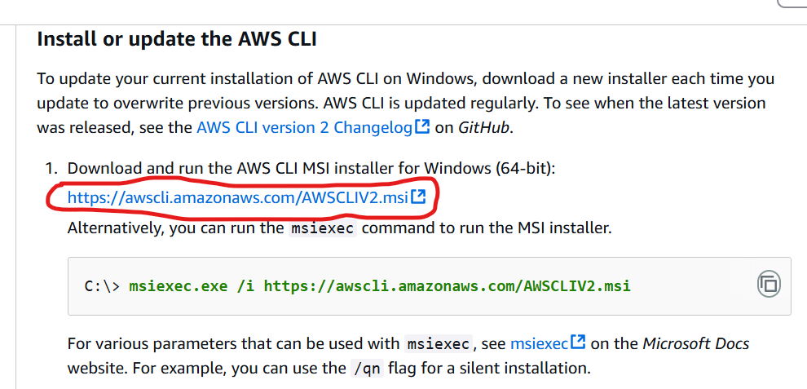

1. Setup Environment variable for terraform.exe path.

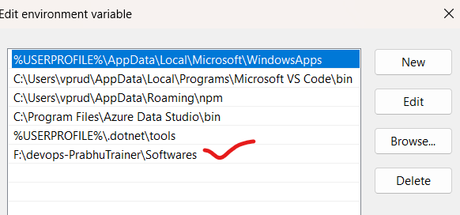

1. Check terraform version in git bash or cmd

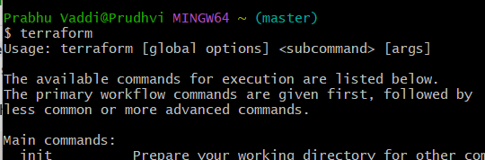

1. Install Visual studio code and create terraform/ec2 folder with provider.tf file

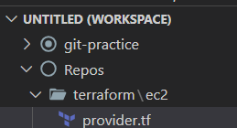

1. Providers : aws

<https://registry.terraform.io/providers/hashicorp/aws/latest>

Copy the code & paste into provider.tf in vs code

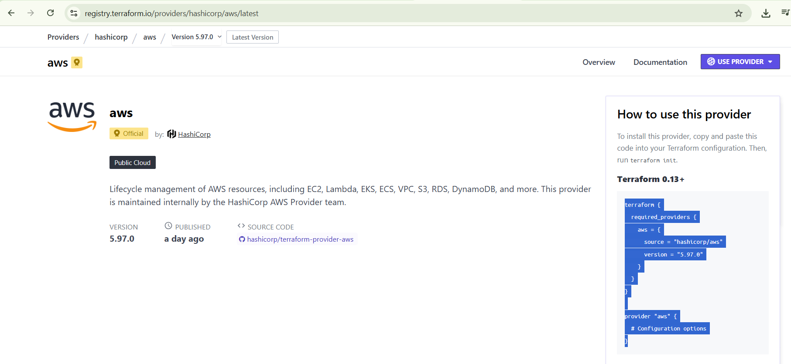

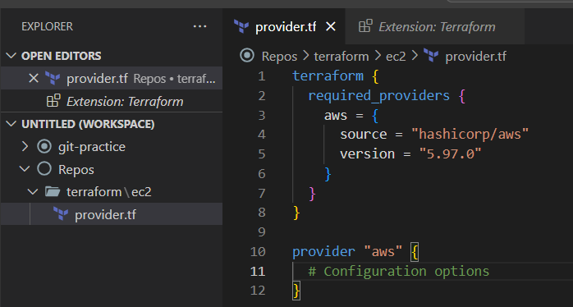

1. Set AWS configure cmd in git bash.

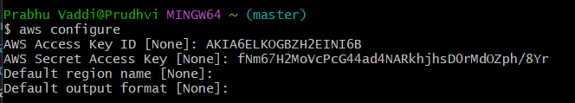

1. Provide access and secret key from aws console.
2. Create a user-terraform using IAM
3. Policies- administrationaccess
4. Once, user created=> security credentials=> create secret/access key

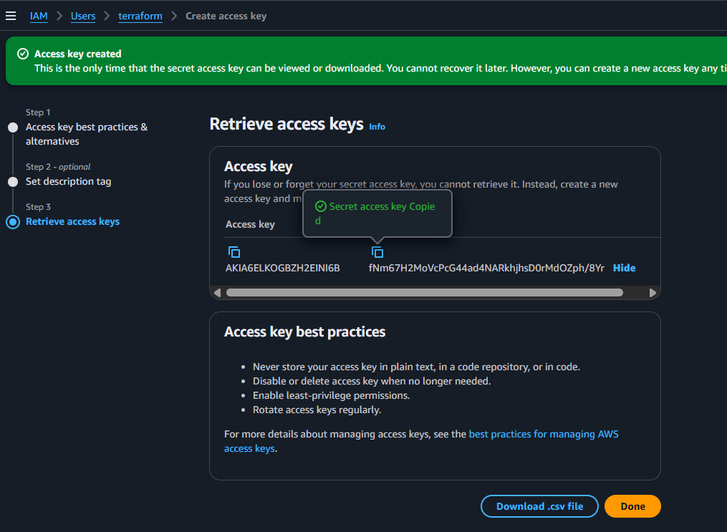

1. Edit the provider.tf with region etc.,

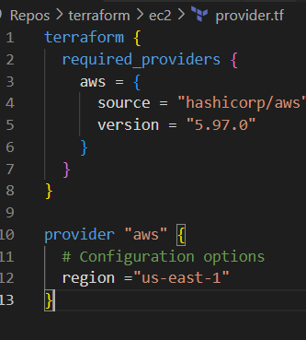

1. Create a new file under ec2=> ec2.tf

Security_Group creation

<https://registry.terraform.io/providers/hashicorp/aws/latest/docs/resources/security_group>

**Notes**

1. Name
2. Description
3. Ingress =>incoming traffic mandatory
4. Egress => outgoing traffic mandatory

**Security Group Code**

resource "aws_security_group" "allow_ssh_terraform" {

    name = "allow_sshh" #allow_ssh is already there in my account

    description = "Allow port no 22 for ssh access"

    #usually we allow everything in egress

    egress {

    from_port        = 0

    to_port          = 0

    protocol         = "-1"

    cidr_blocks      = ["0.0.0.0/0"]

    ipv6_cidr_blocks = ["::/0"]

  }

  ingress {

    from_port        = 22

    to_port          = 22

    protocol         = "tcp"

    cidr_blocks      = ["0.0.0.0/0"] #allow from everyone

    ipv6_cidr_blocks = ["::/0"]

  }

    tags = {

    Name = "allow_sshh"

  }

}

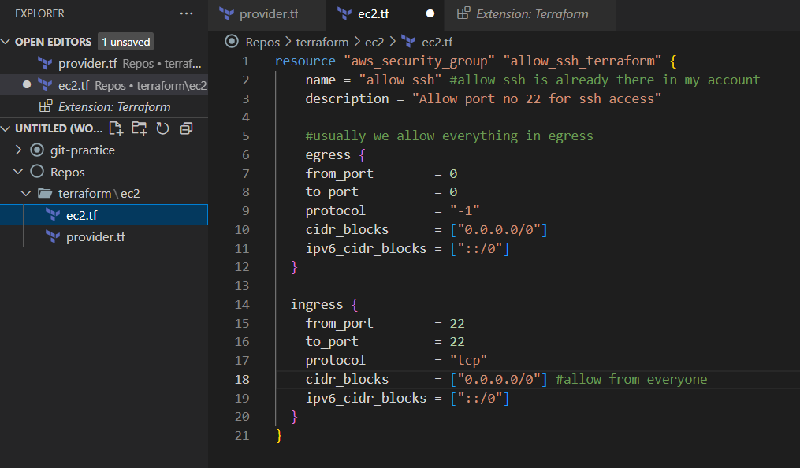

1. Terraform init => connect with provider and download it.

Whereever tf files, that directory is eligible to run the terraform init operation

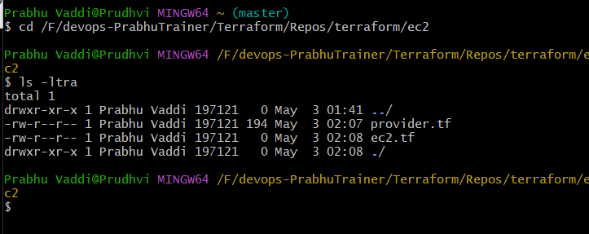

CMD : terraform init

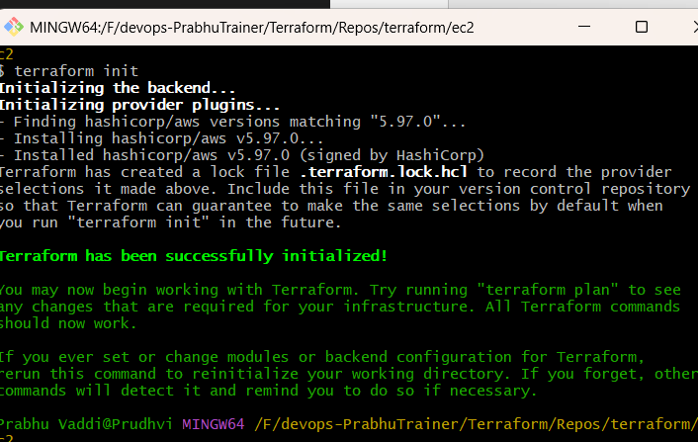

Open vs code=> few files added/download

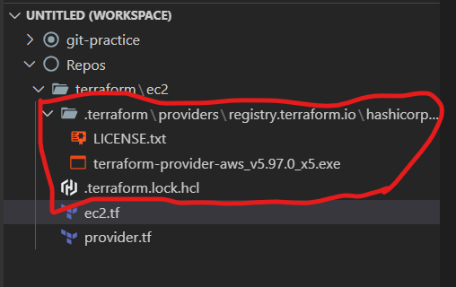

1. GIT IGNORE => Mandatory
2. These files are not push into git repo. So, terraform .gitignore helps for us.

<https://github.com/github/gitignore/blob/main/Terraform.gitignore>

Note : Create a file => .gitignore=> Copy & paste into vs code

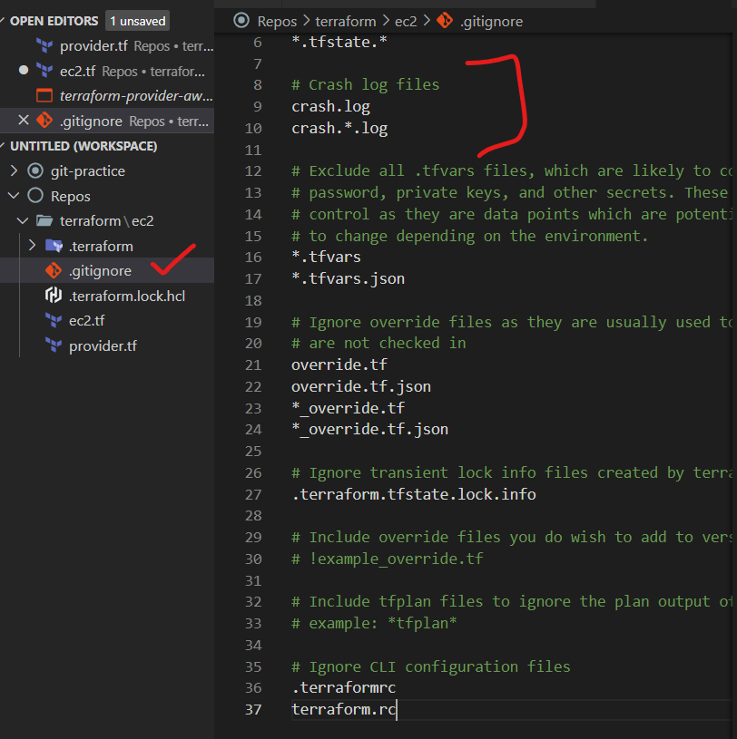

PLAN

1. Tell resources using plan.

Cannot create resources, it is just plan

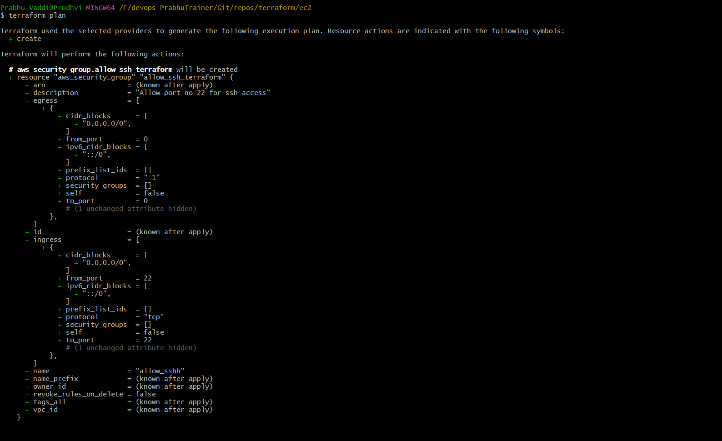

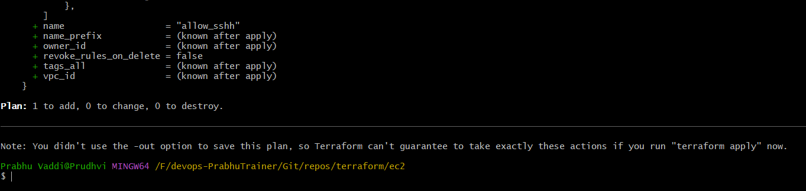

APPLY

1. Tell resources using apply=> effect the resources.

Plan => stage

Apply => commit

CMD : terraform apply

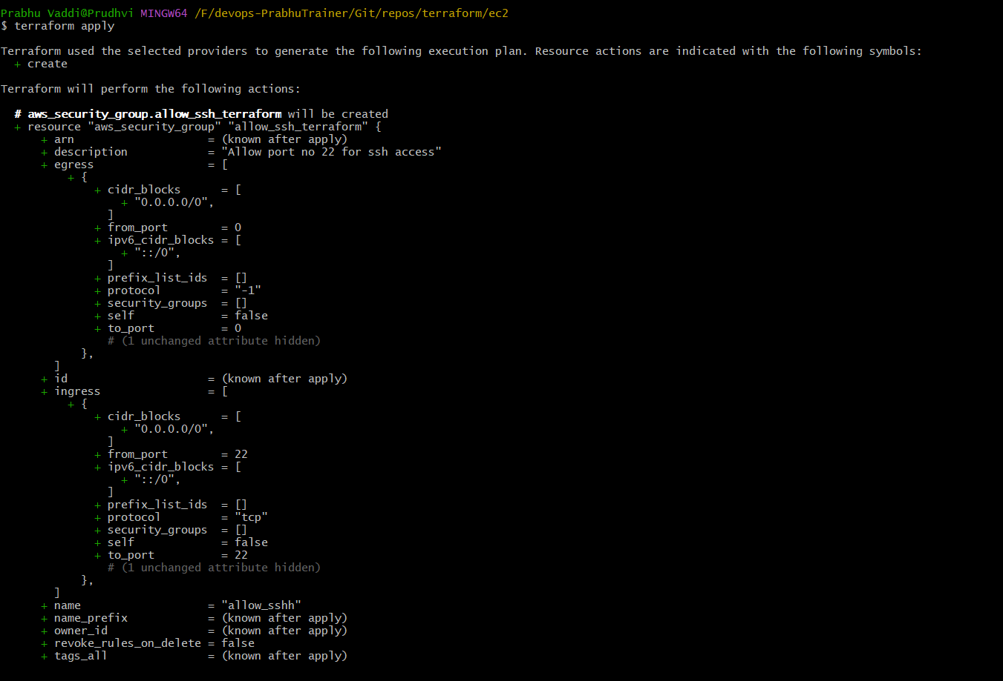

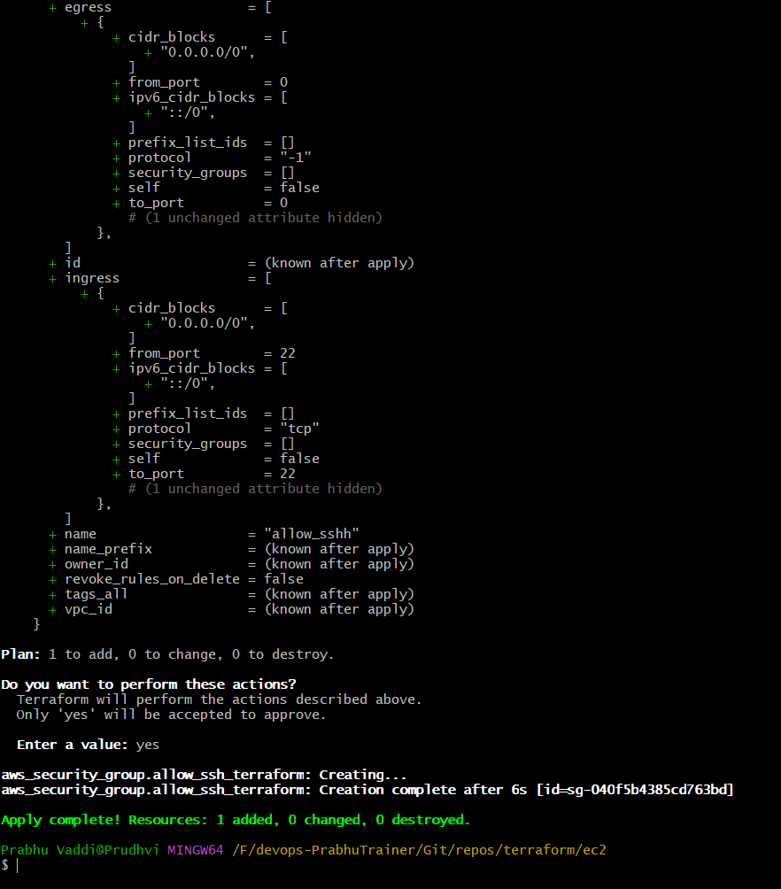

Successfully created security group & ec2

1. Validate the Resources in AWS

Check Security group

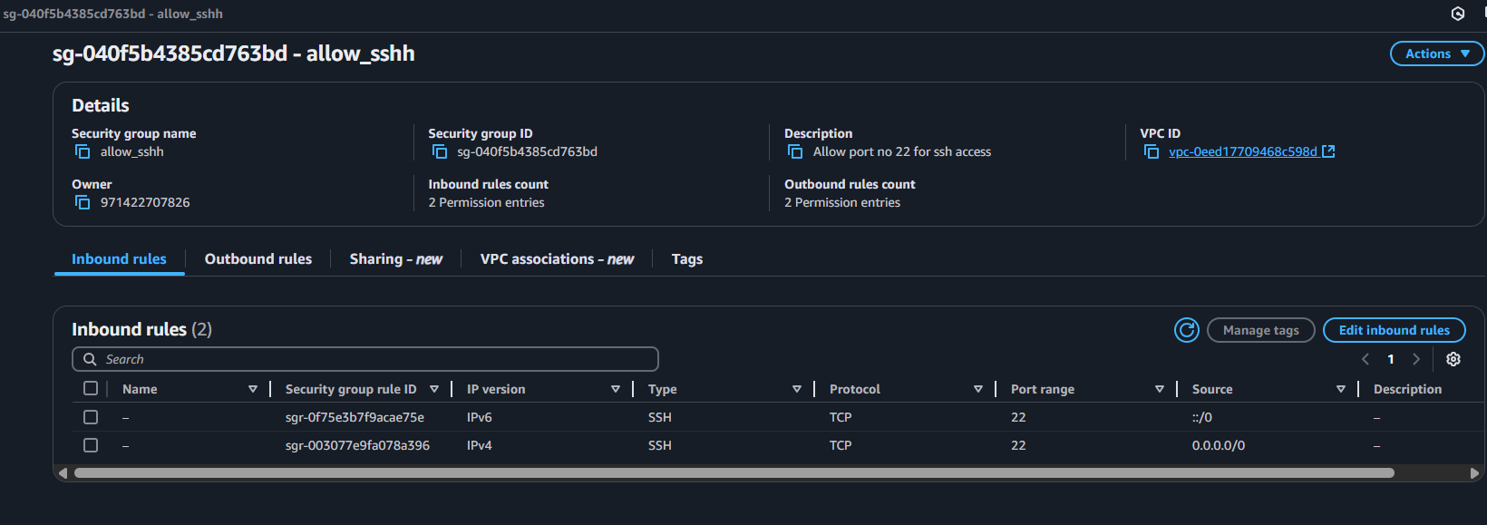

1. Modify the security group with tag => Name : allow_sshh. Next => plan & apply.

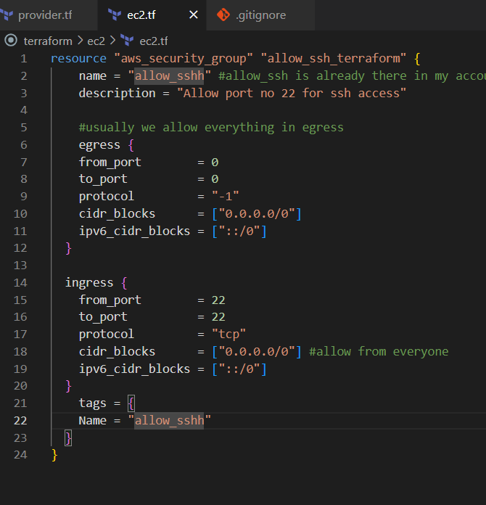

1. Plan in Gitbash

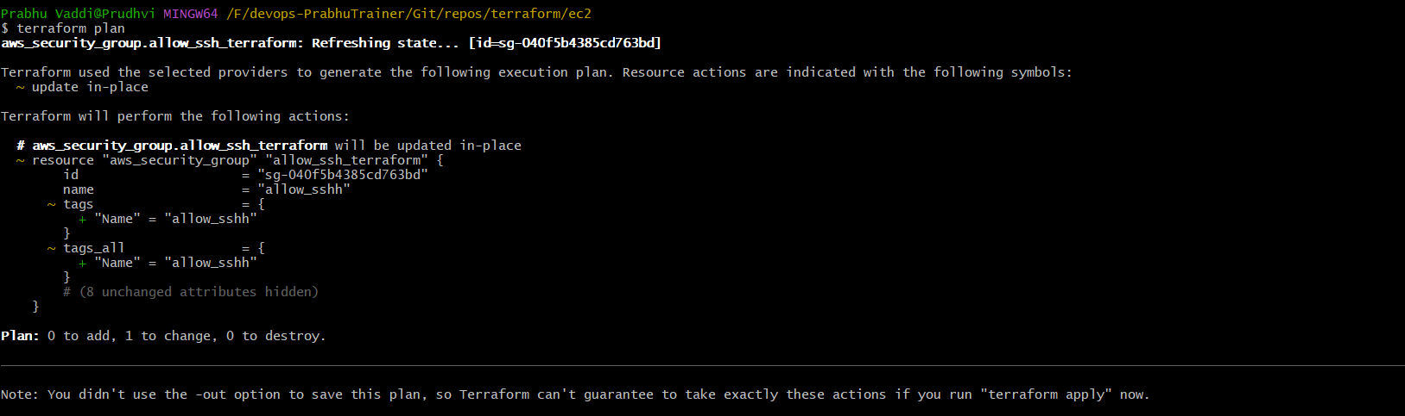

1. CMD: terraform apply -auto-approve

Note : no need to provide “yes”

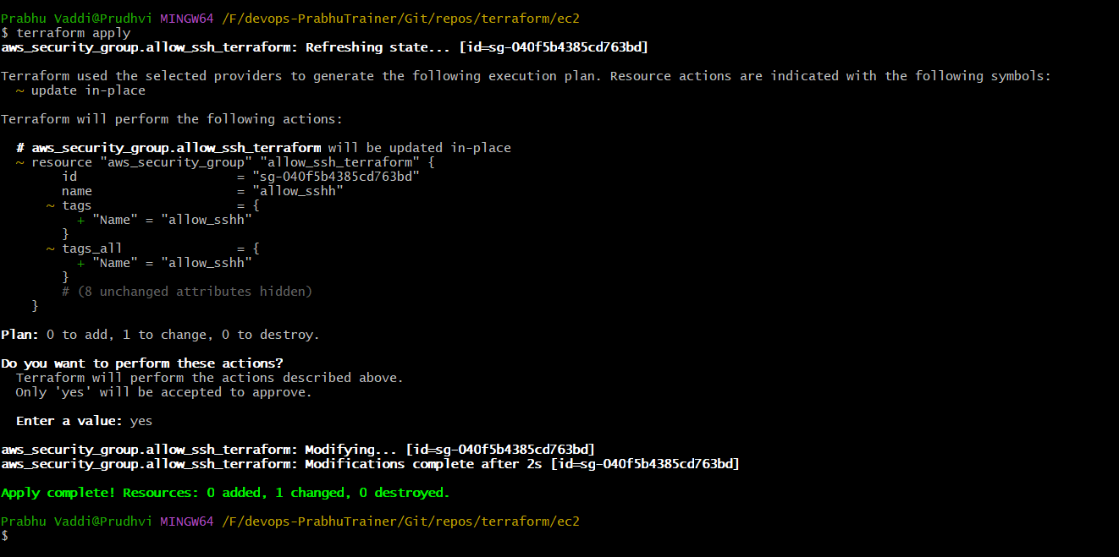

1. Validate => SG

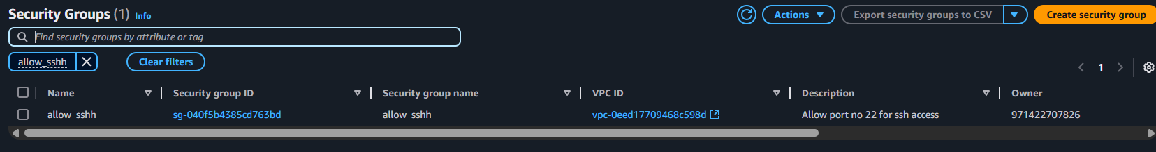

1. Added EC2 Instance

Code

resource "aws_instance" "terraform" {

  ami           = "ami-09c813fb71547fc4f"

  instance_type = "t3.micro"

  vpc_security_group_ids = [aws_security_group.allow_ssh_terraform.id]

  tags = {

    Name = "Terraform"

  }

}

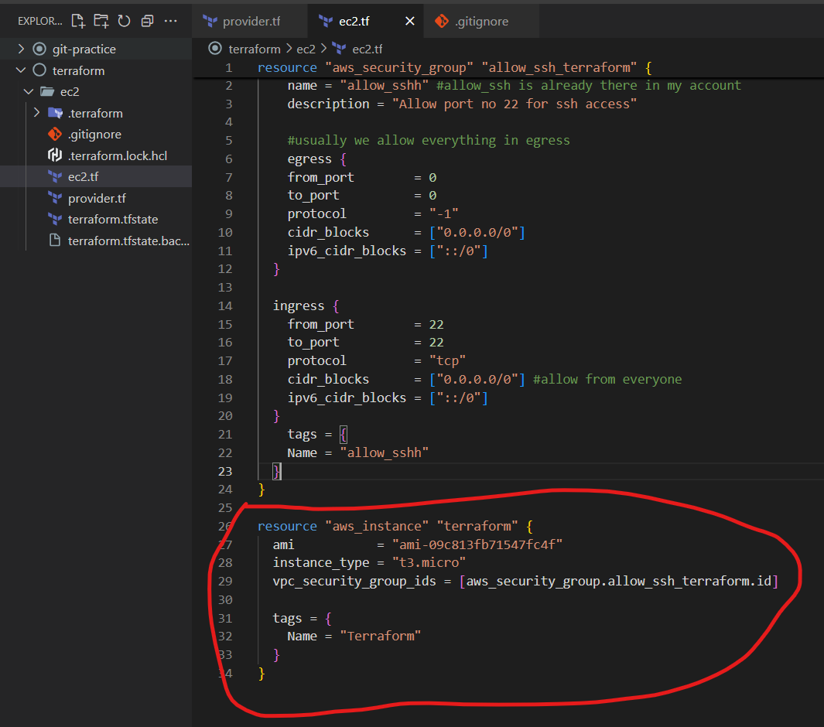

1. Plan & Apply auto save

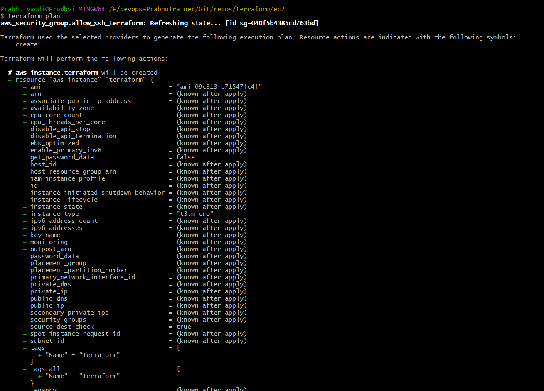

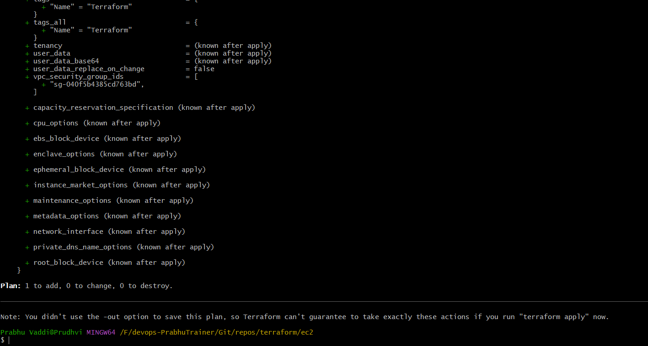

NEXT, Apply -auto-approve

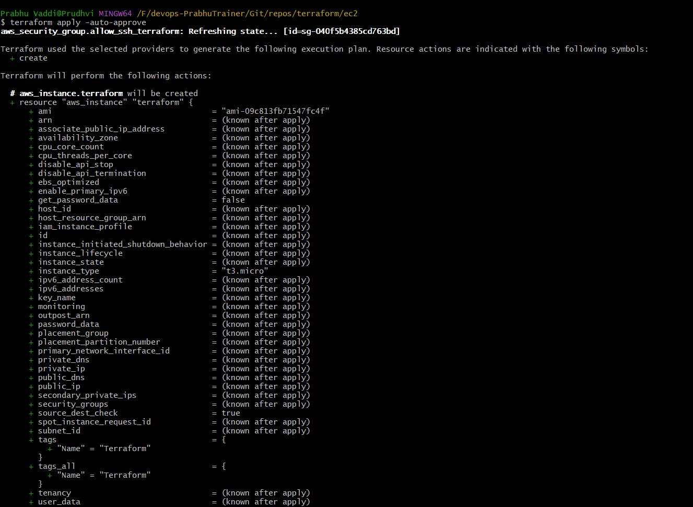

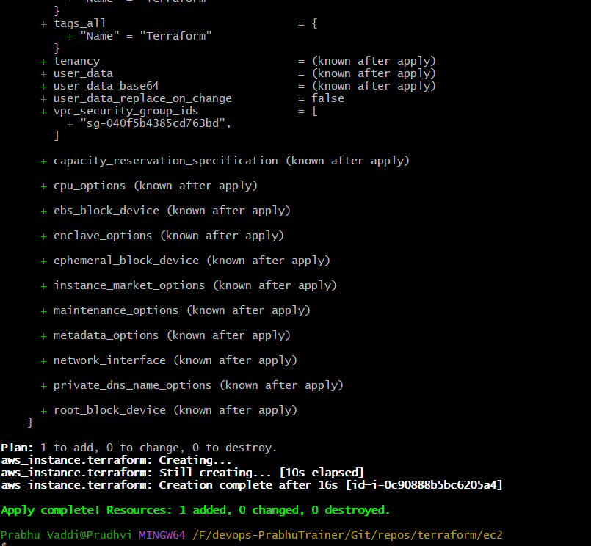

1. Validate the EC2 Instance

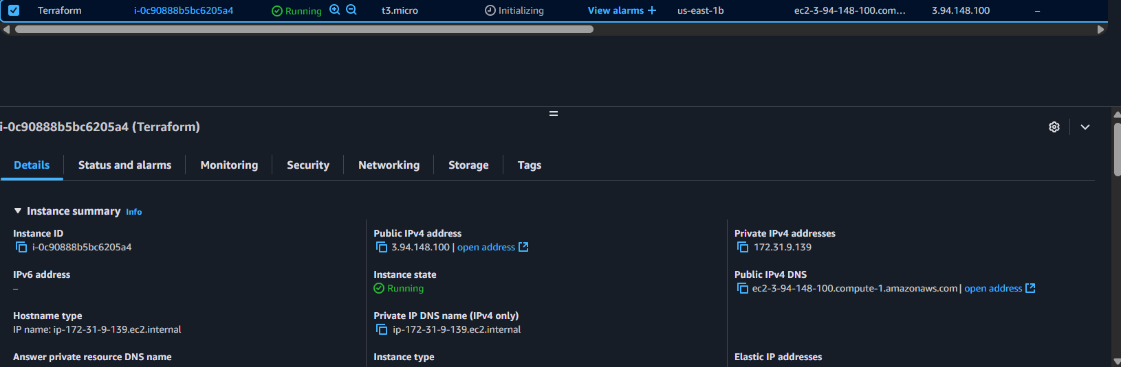

Security Group validation.

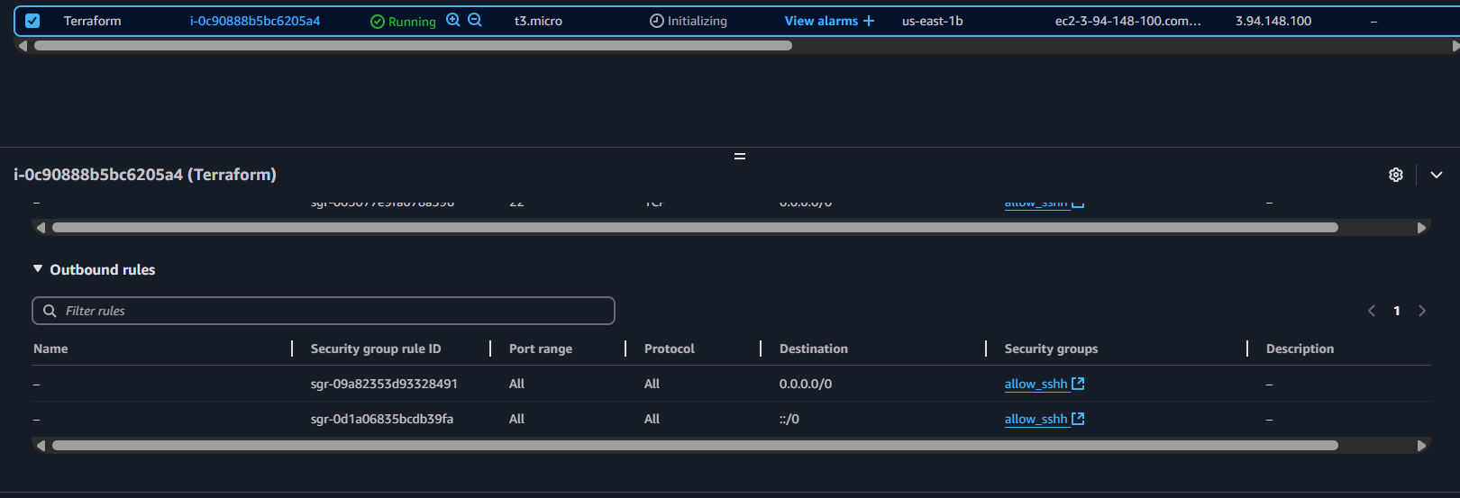

DESTROY

1. CMD : terraform destroy -auto-approve

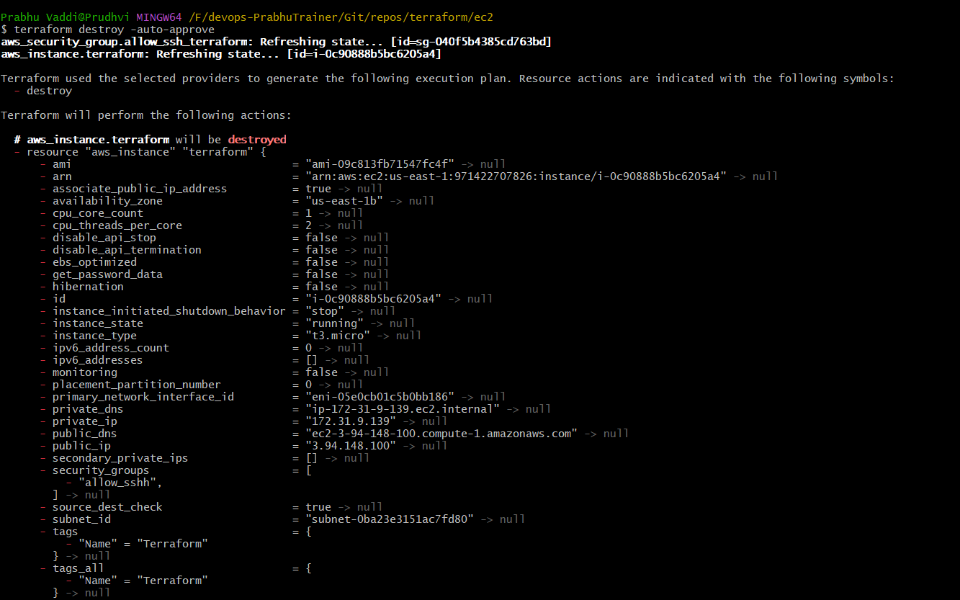

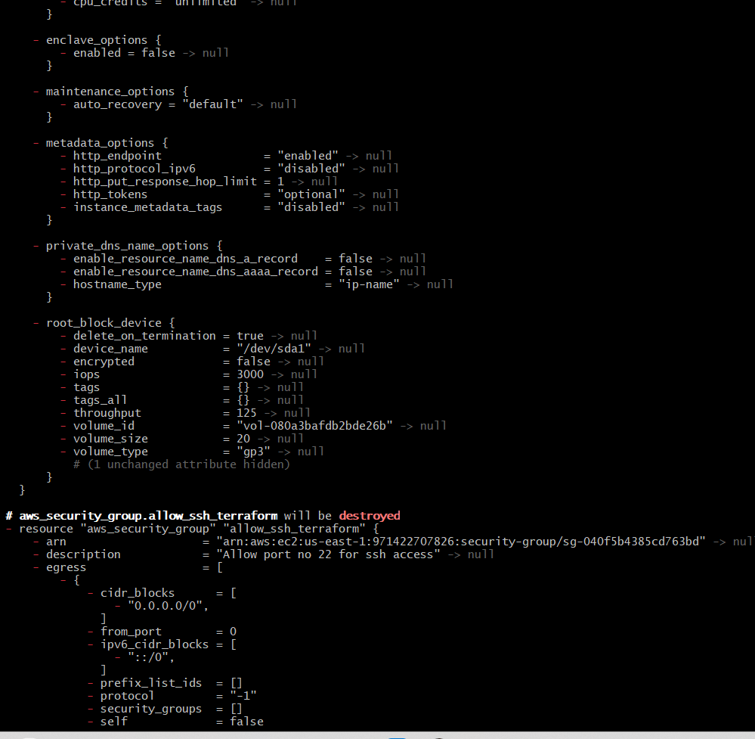

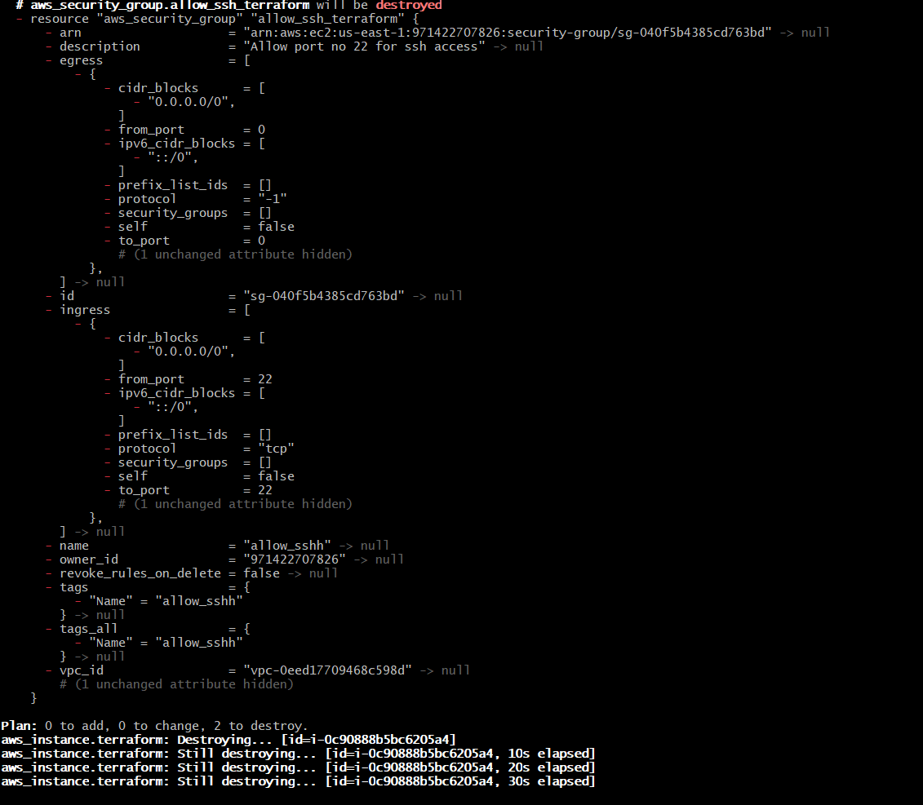

1. Validate the resource after destroy in aws.

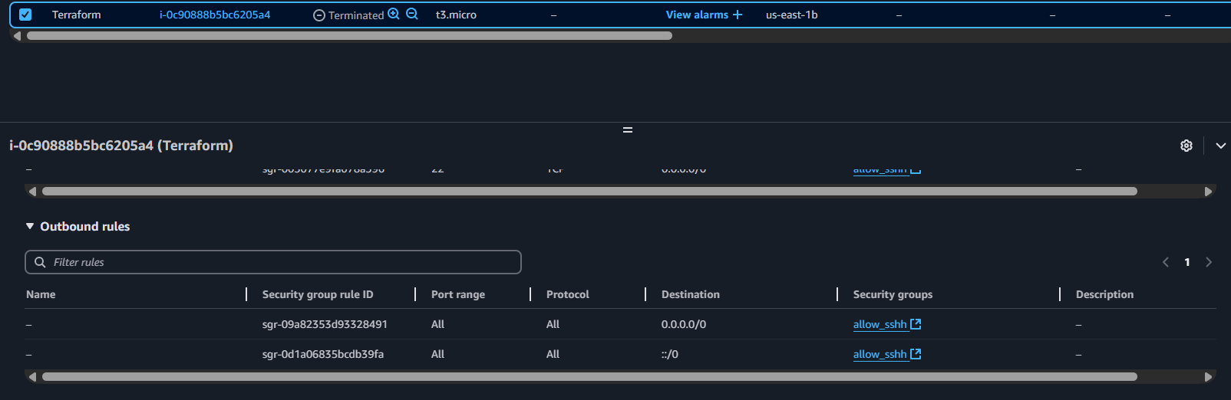

Note: EC2 is depedent on Security Group

1. Variables
2. Conditions
3. Data Types
4. Loops
5. Functions
6. Variables

URL : <https://developer.hashicorp.com/terraform/language/values/variables>

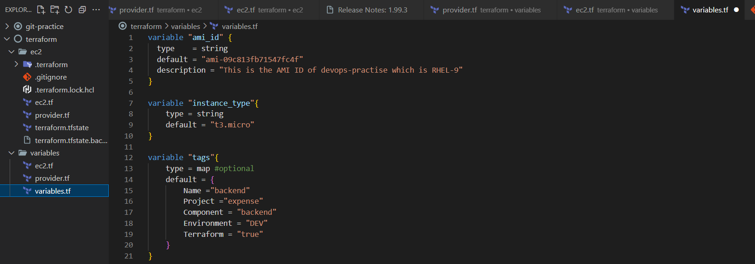

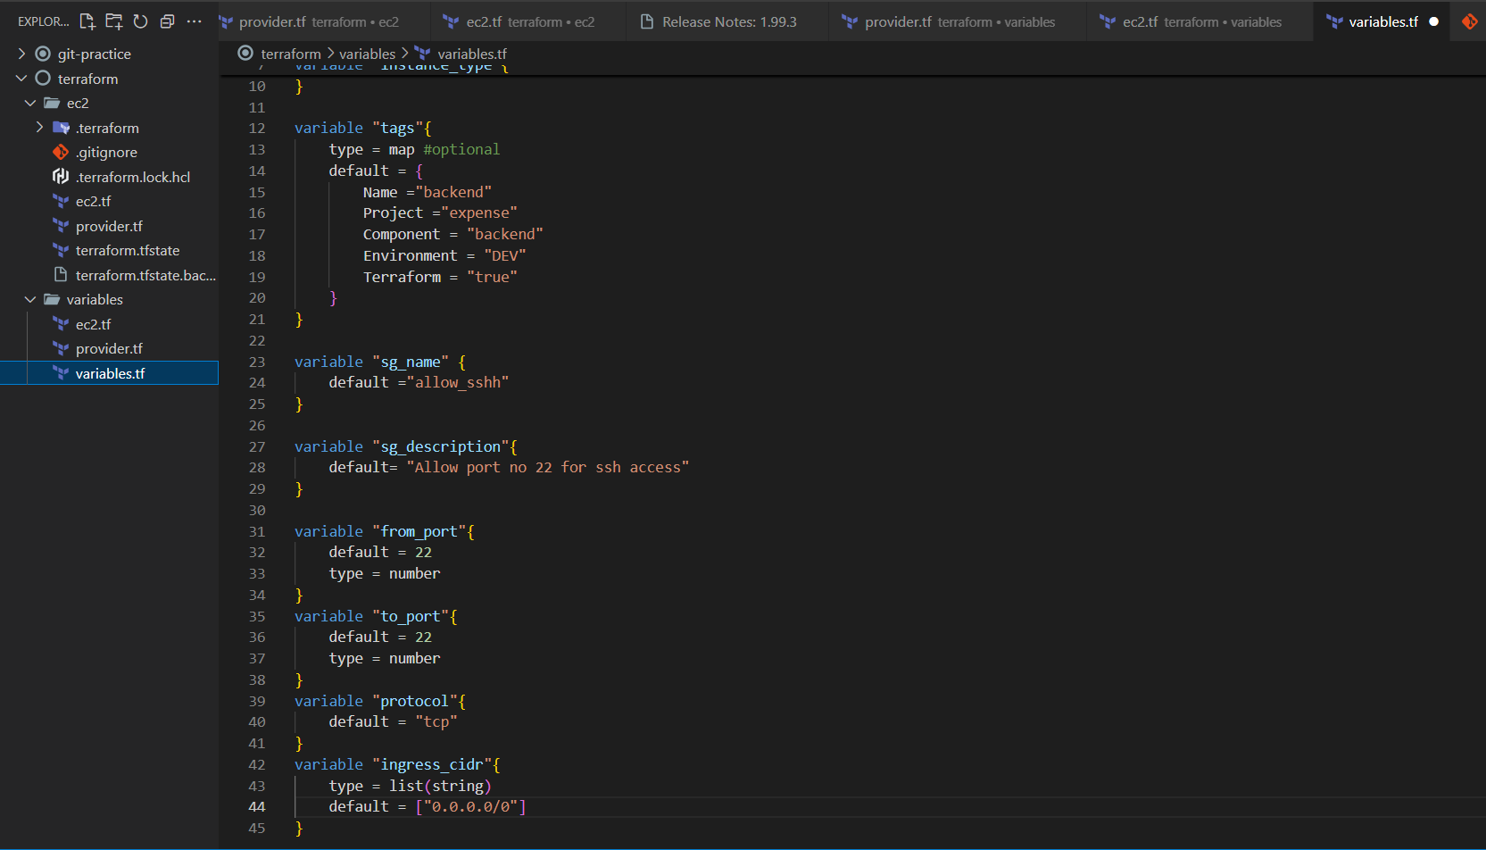

Change static value to dynamic value in ec2.tf.

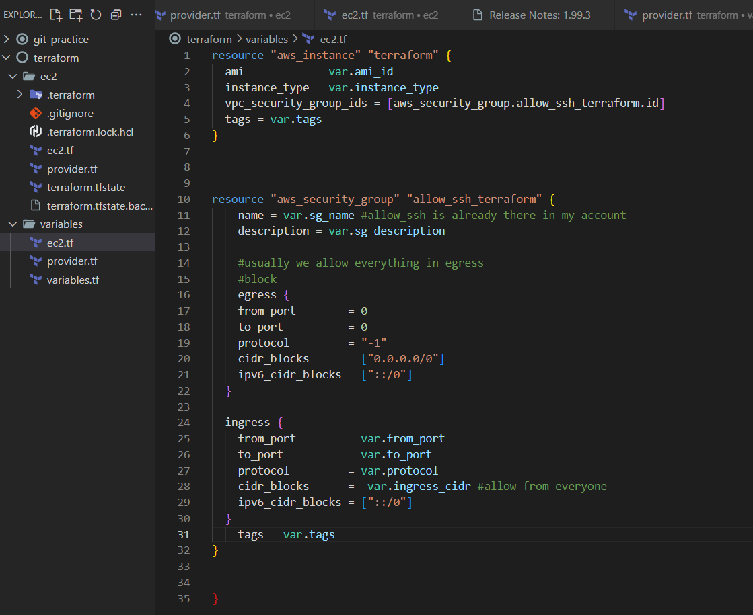

**PUSH THE CODE INTO GIT**

1. Create a nano file with name .bashrc

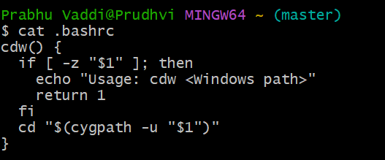

Ctrl+X and Y then Enter

It helps to convert the path backward slash to forwardslash.

**CDW Function**

cdw "F:\devops-PrabhuTrainer\Git\repos\terraform"

PUSHING THE CODE from Local to GIT Repo

1. Git init
2. ls -ltra

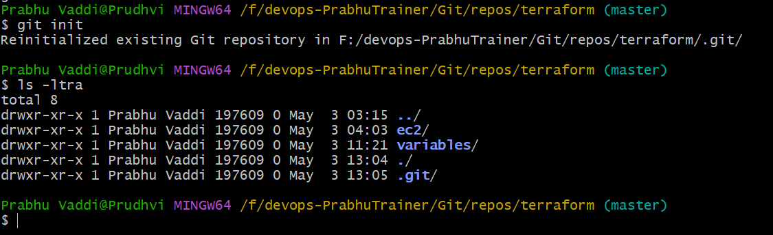

1. git status , git add .

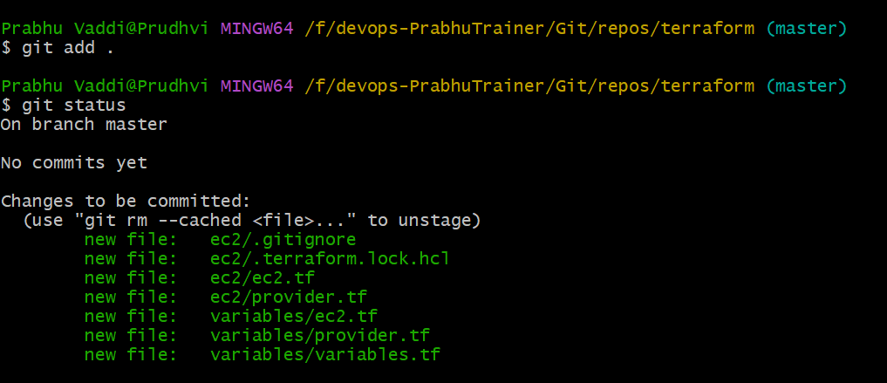

1. git commit

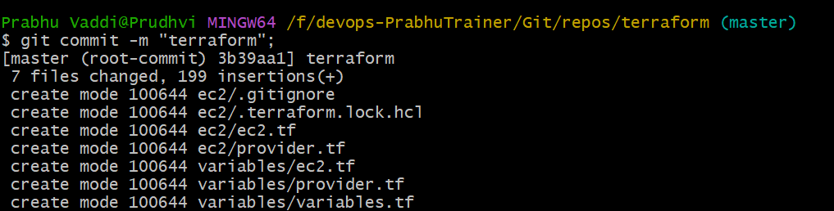

1. git push => NO Repository exist in GITHUB

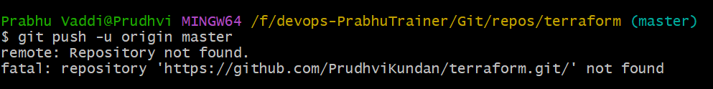

1. Create a repository in GIT HUB.

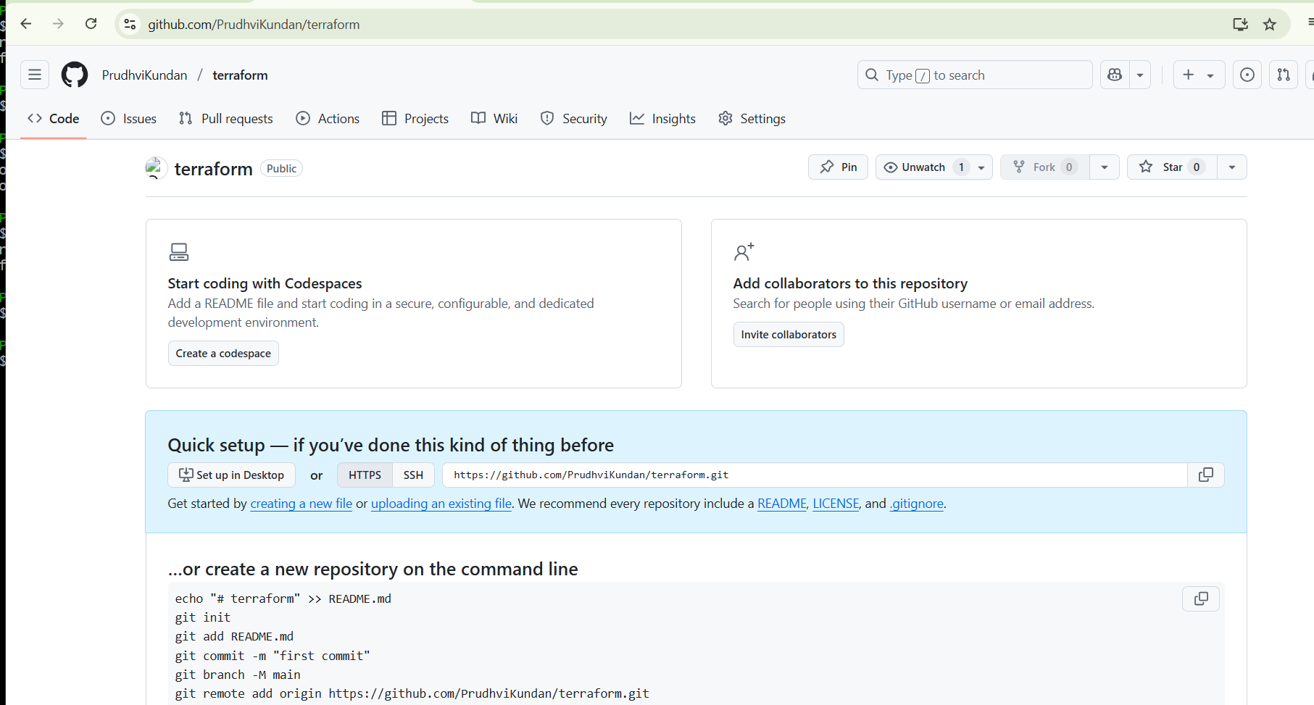

1. Follow this steps in GIT BASH

git branch -M main

git remote add origin https://github.com/PrudhviKundan/terraform.git

git push -u origin main

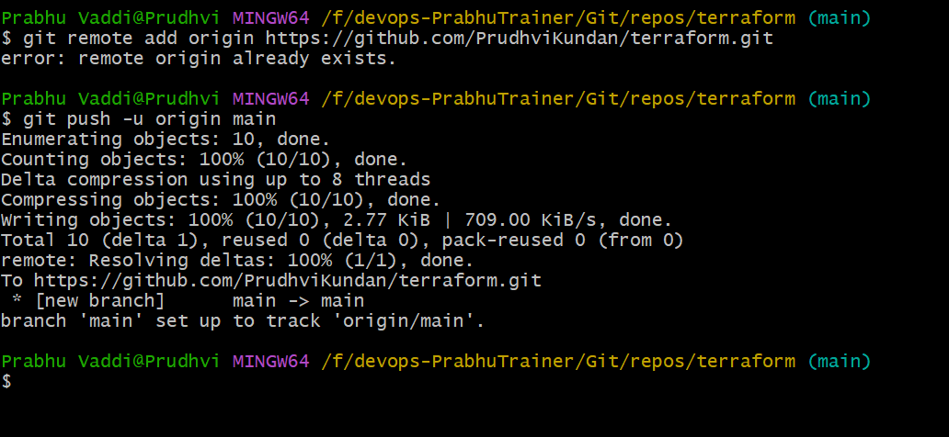

**Validate GIT Repo - Terraform**

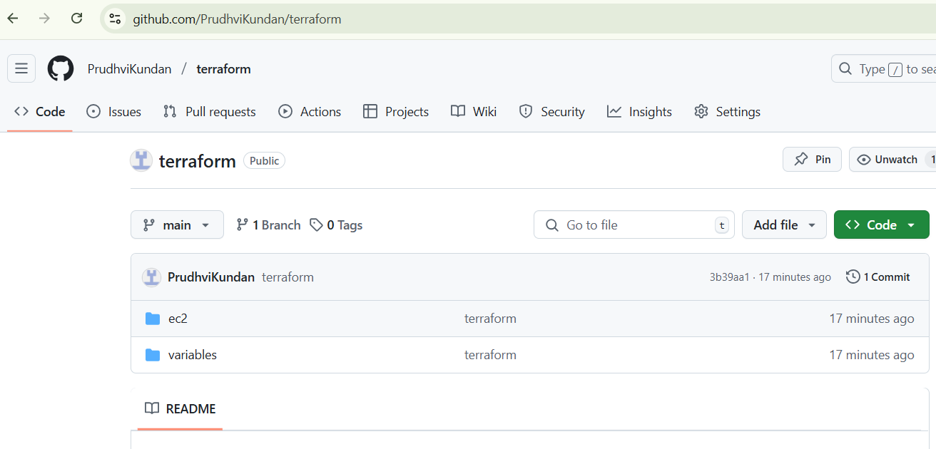

**Variables**

In GIT BASH=> Terraform initialization for variables section

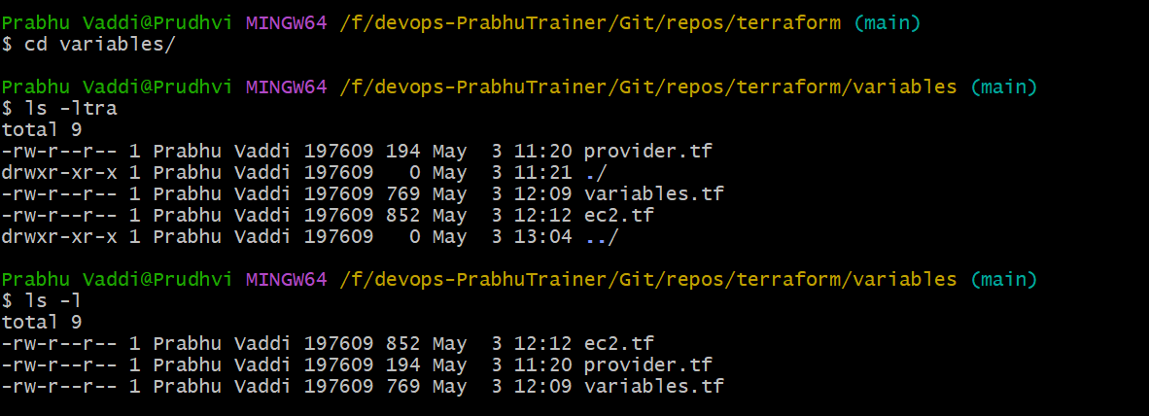

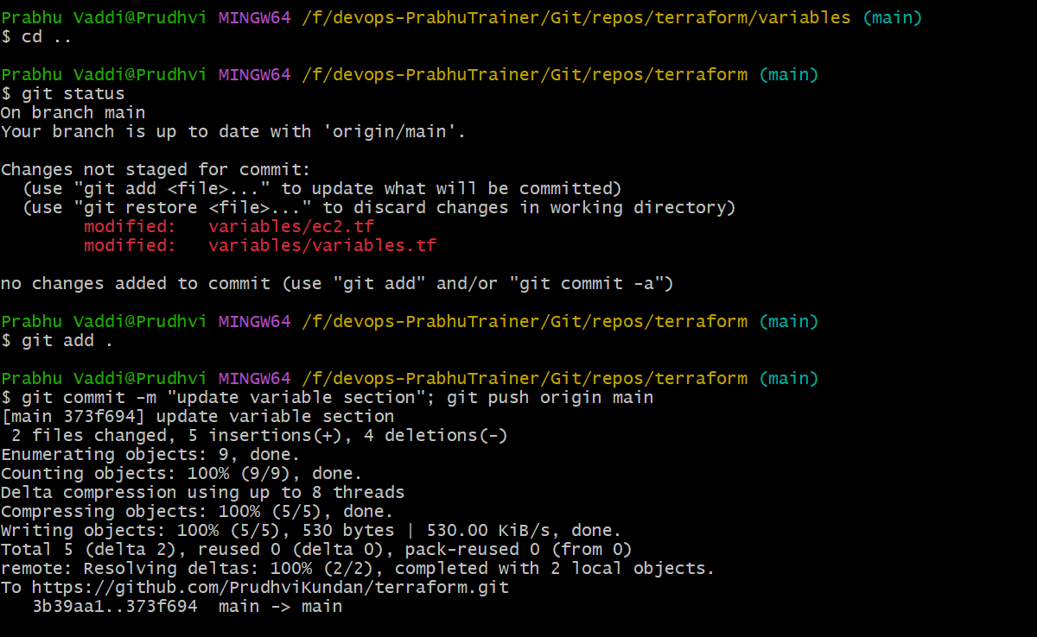

**Terraform Plan for variable section**

Once, code deployed into git. Next, Changes are happened to different directory (variables).

Start the terraform commands.

1. First time – terraform init

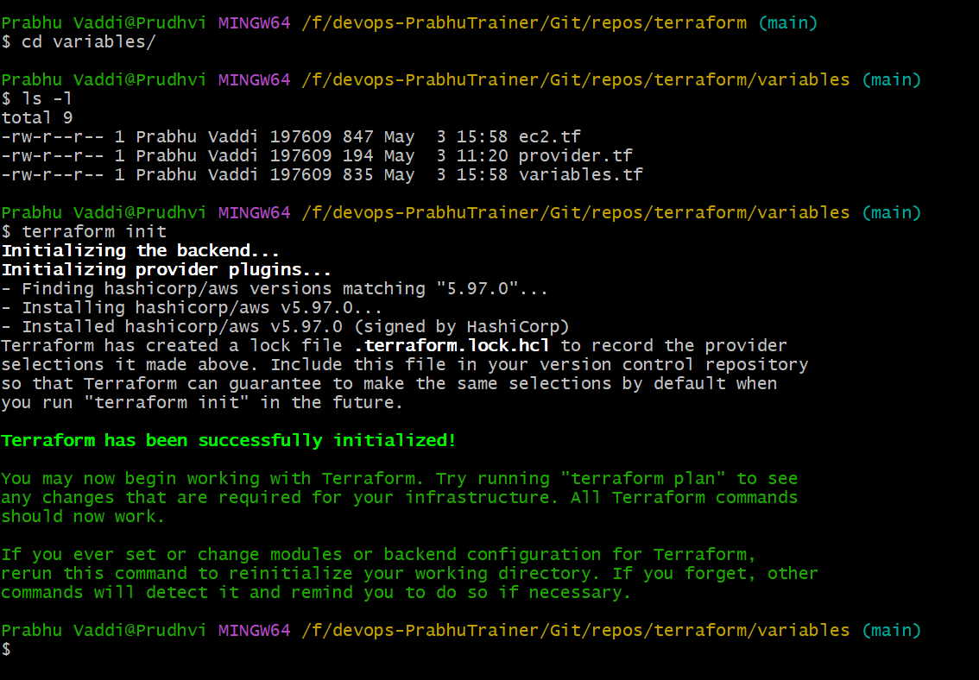

Terraform Plan => Just staging

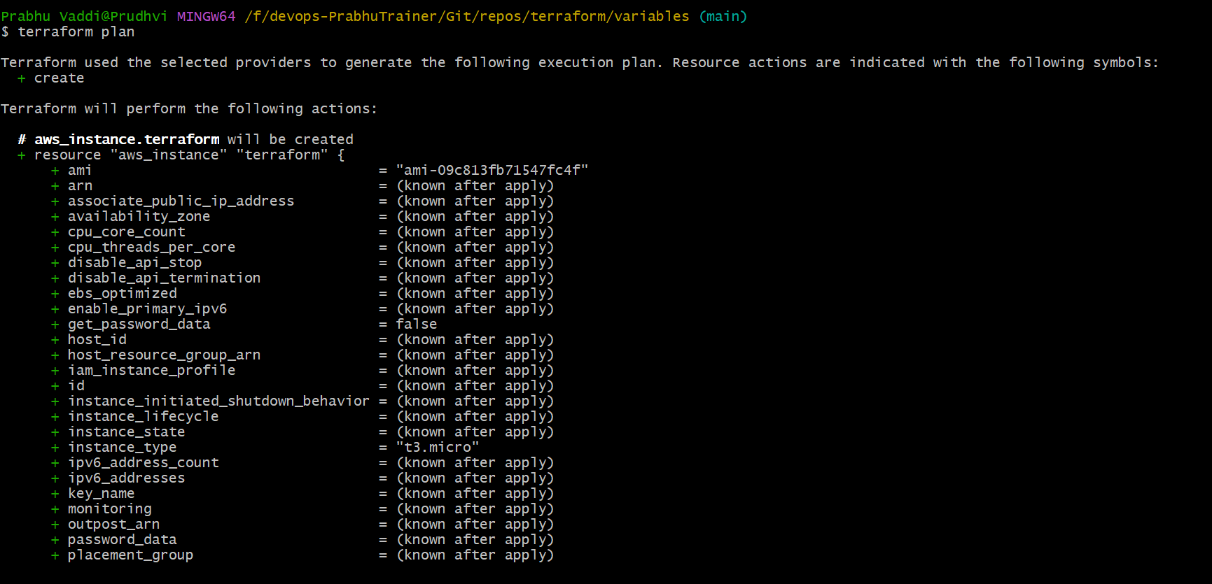

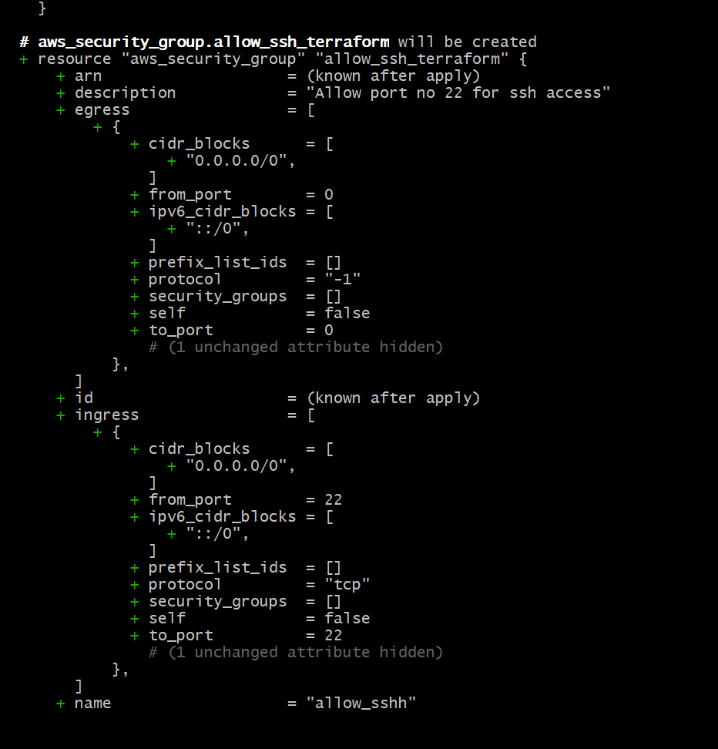

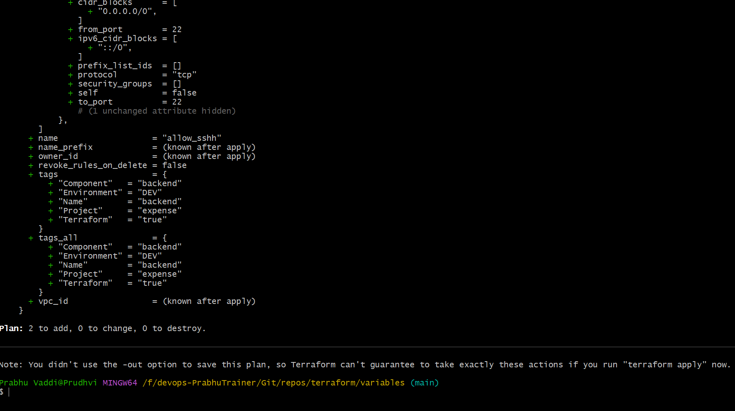

1. Terraform apply -auto-approve

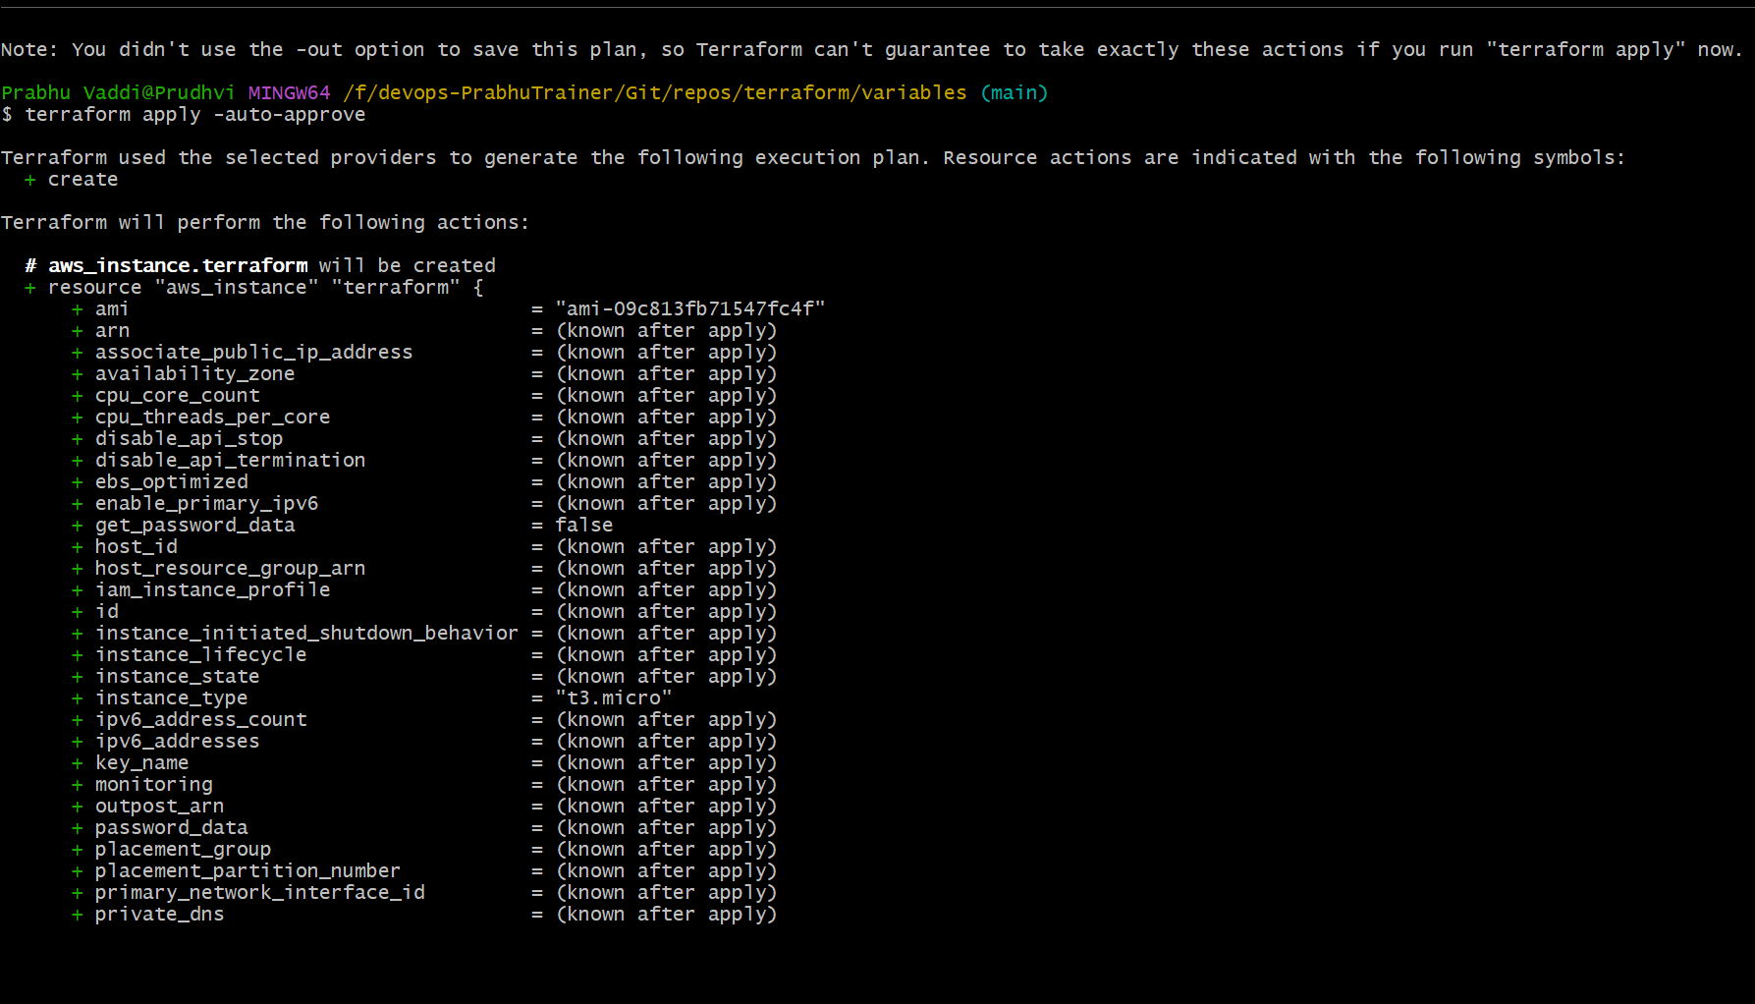

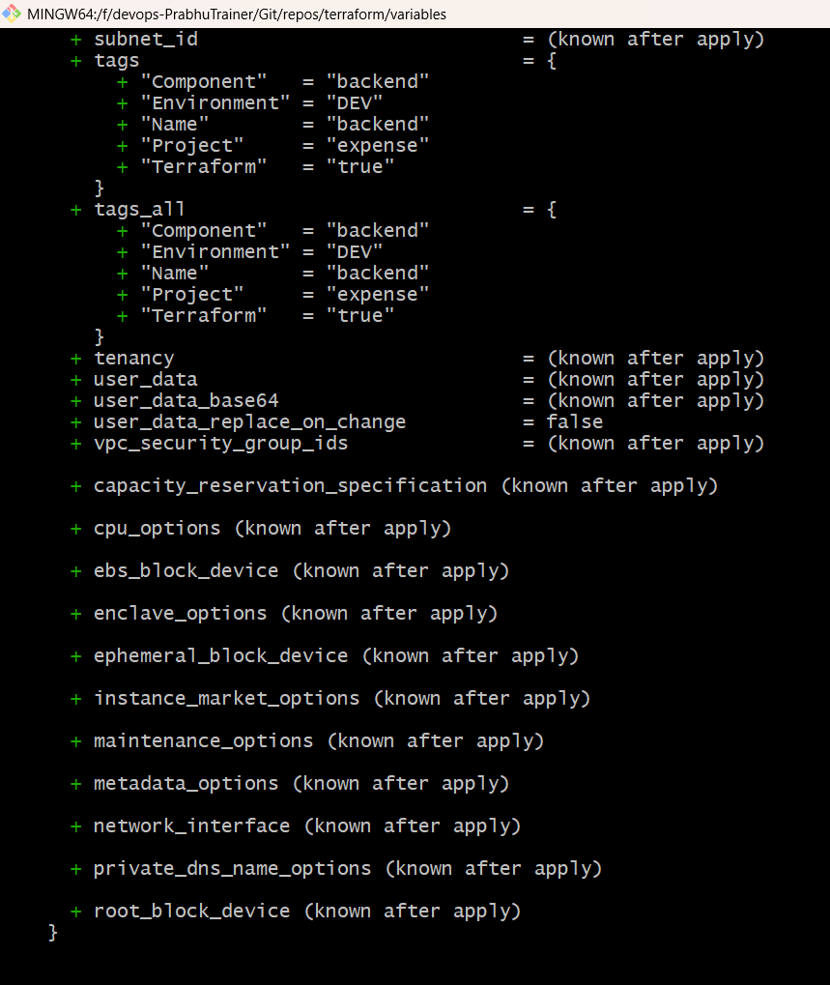

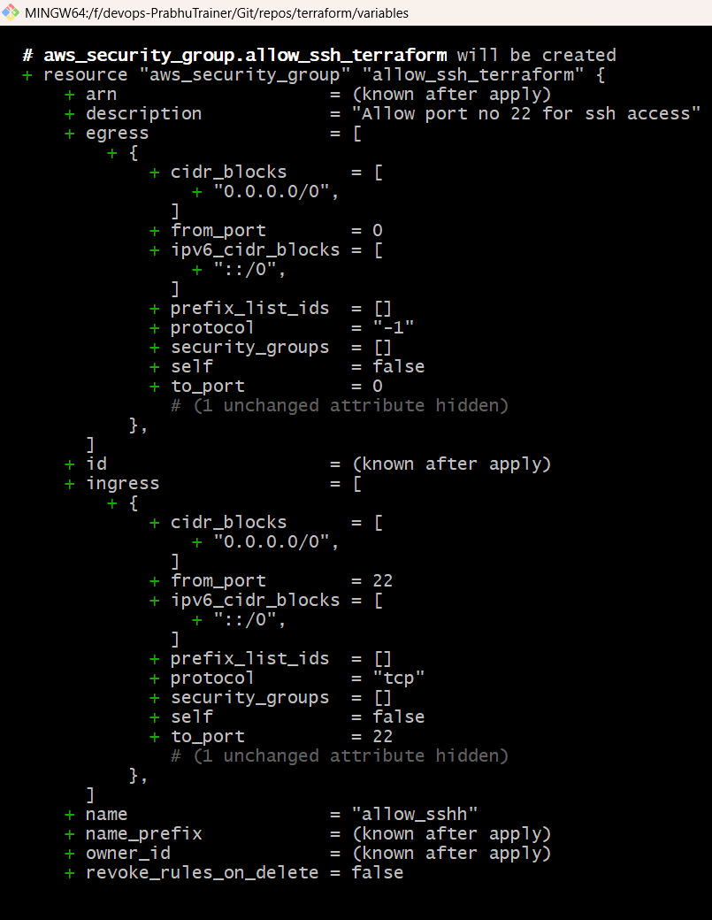

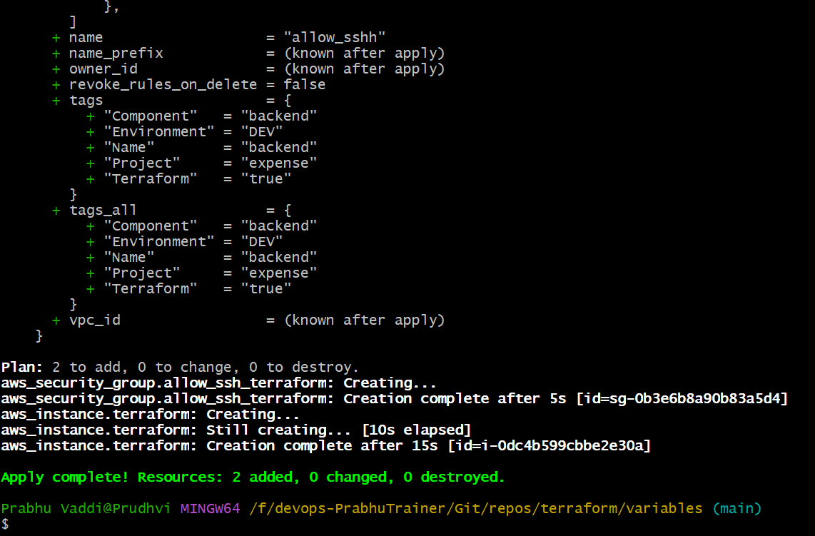

1. Validate in AWS Console

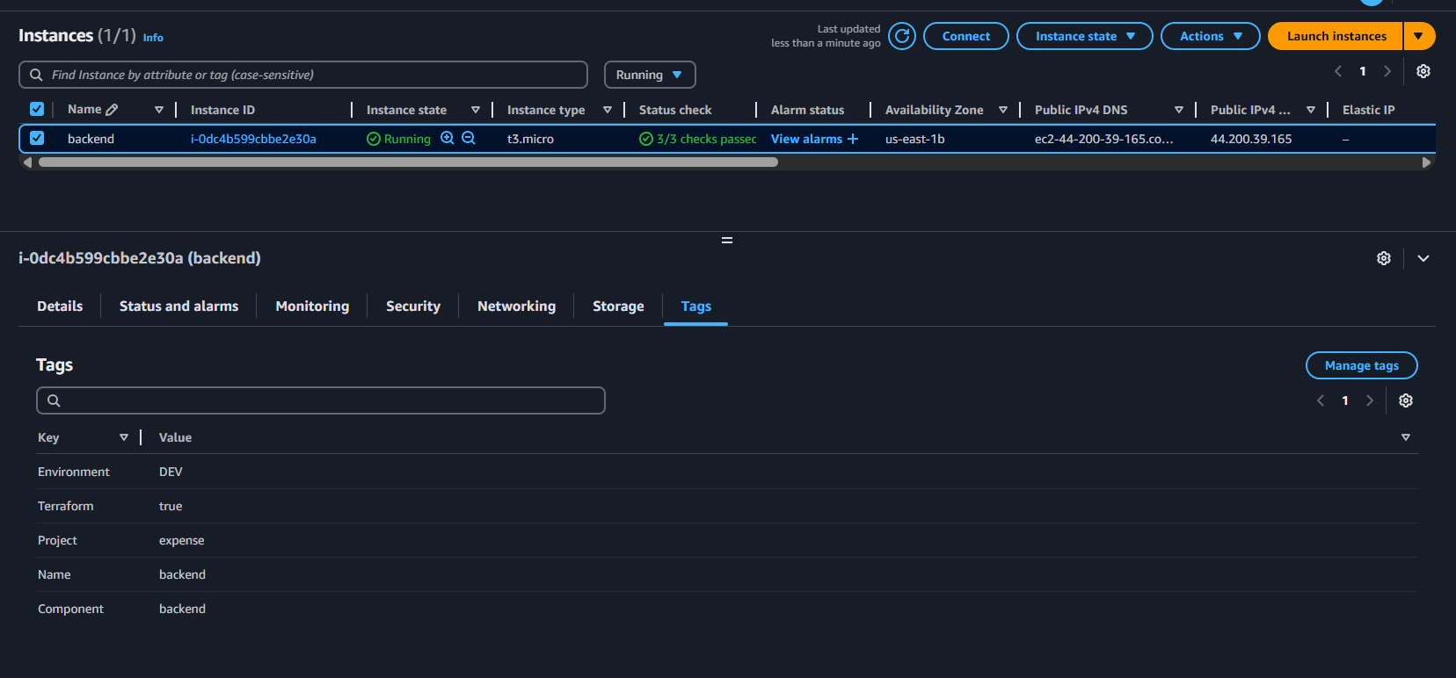

**Security**

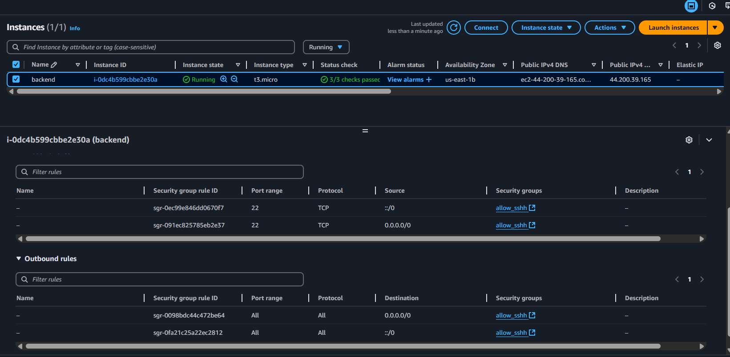

**Terraform.tfvars –** using this file, we can override the default values in variables or else we can set the values

First Preference – tfvars

Second preference – default

1. Commandline – 1st Preference
2. TFVARS – 2nd Preference
3. Environmental variables – 3rd Preference
4. Default – 4th Preference

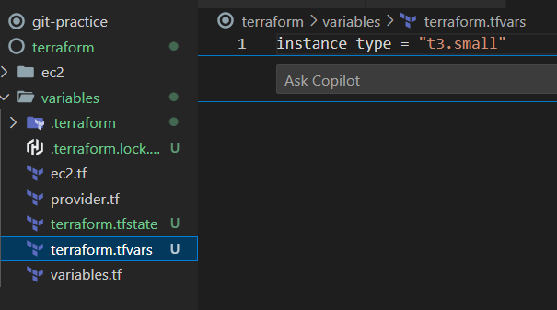

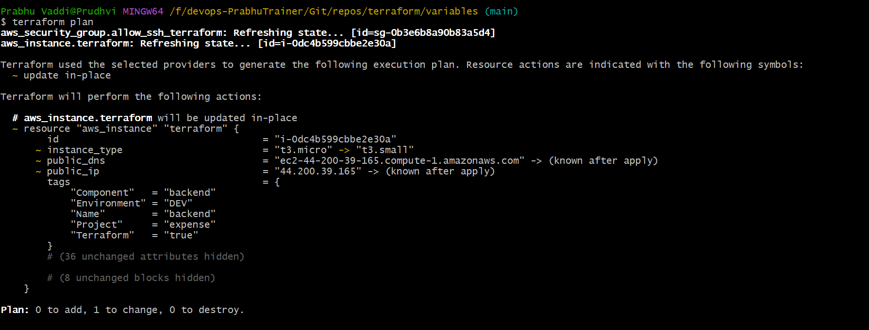

**Command Line**

**CMD : terraform plan -var="instance_type=t3.large"**

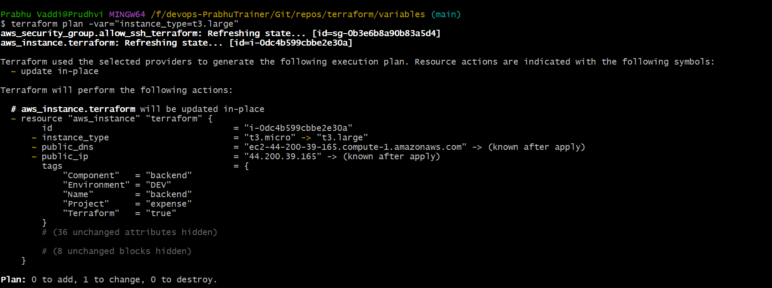

**Environmental variable**

**CMD :** export TF_VAR_instance_type =t3.xlarge

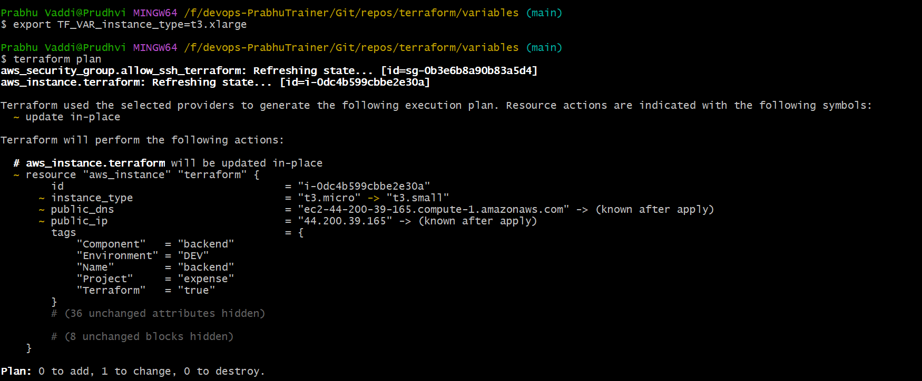

1. **DEFAULT : committed tfvars in code**

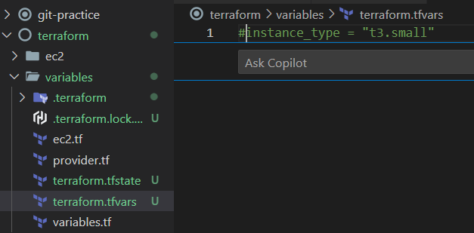

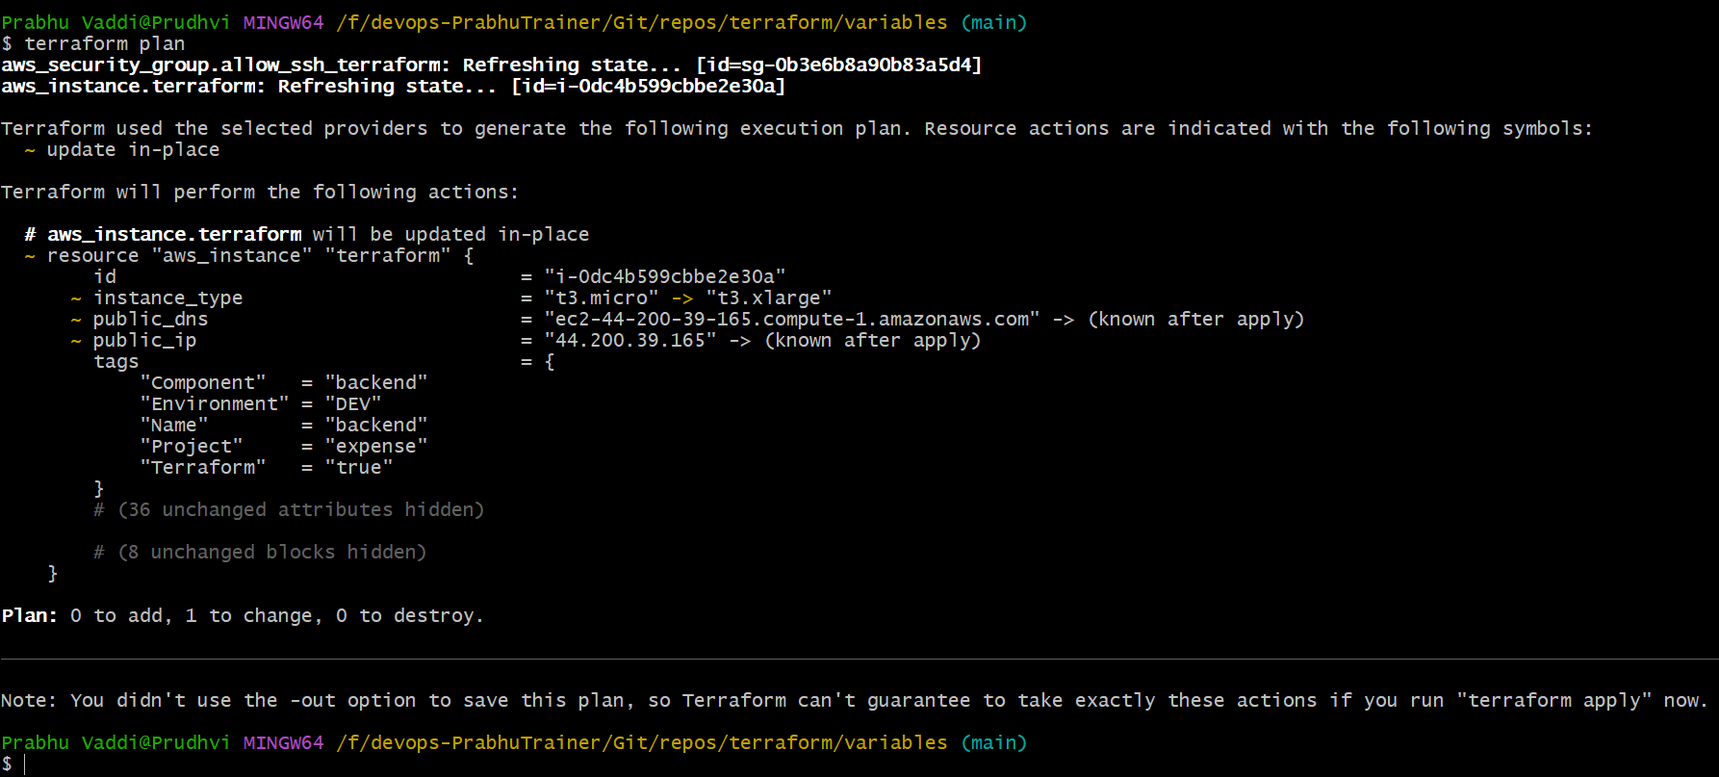

**Comment Instance_Type & Unset Environment variable**

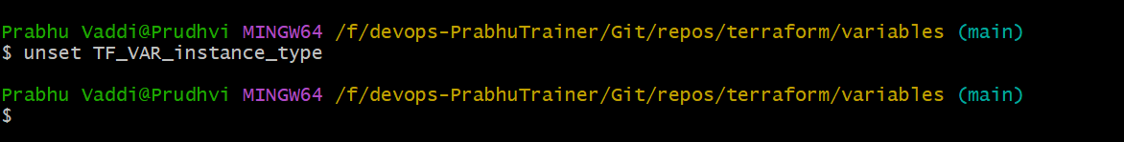

**It is checking all places , but nothing found. So, it is asking enter the value**

**des**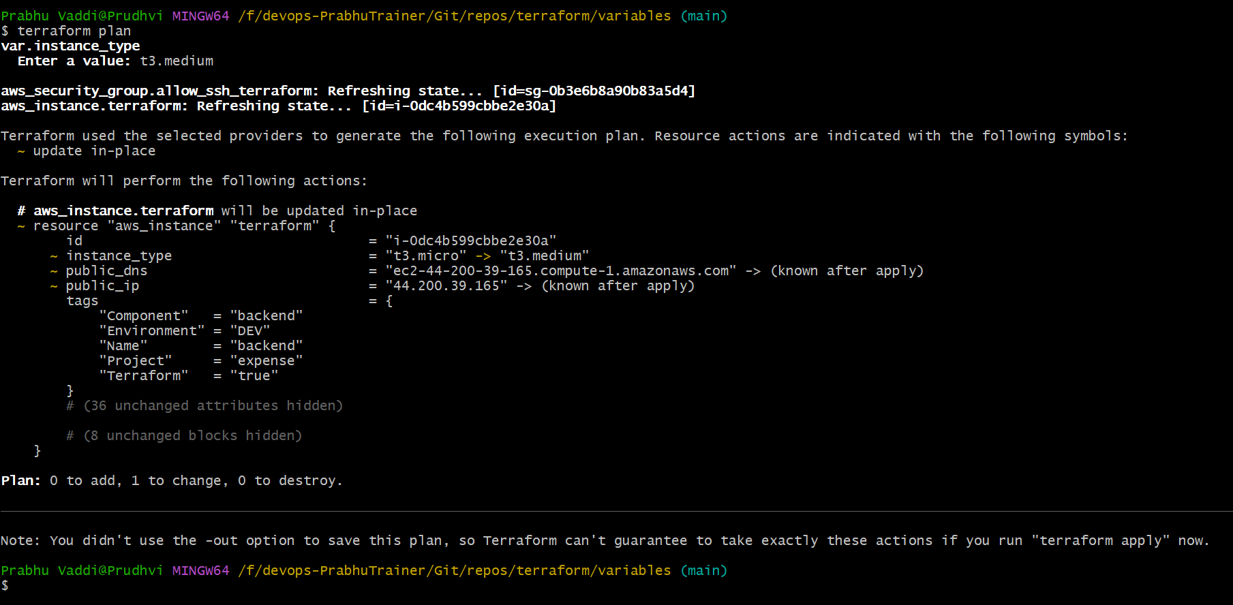

**DESTORY**

1. Terraform destroy -auto-approve

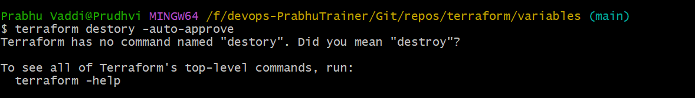

**Validate EC2 instance in AWS. Nothing is running after destroy**

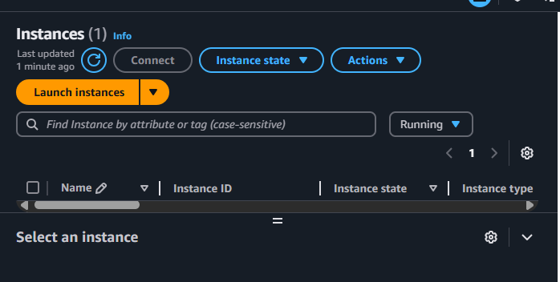

CONDITIONS

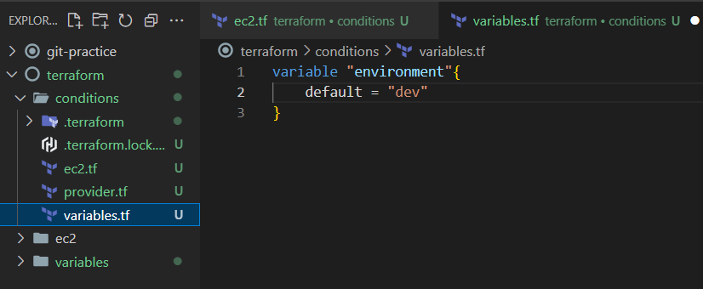

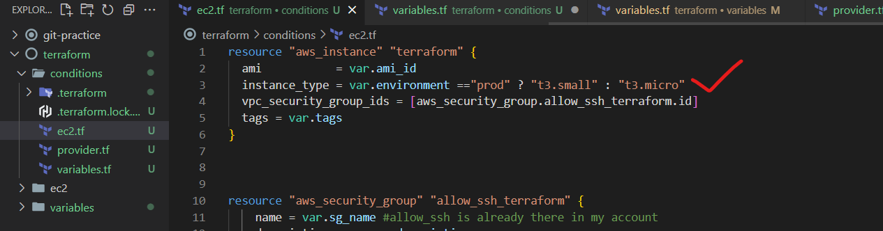

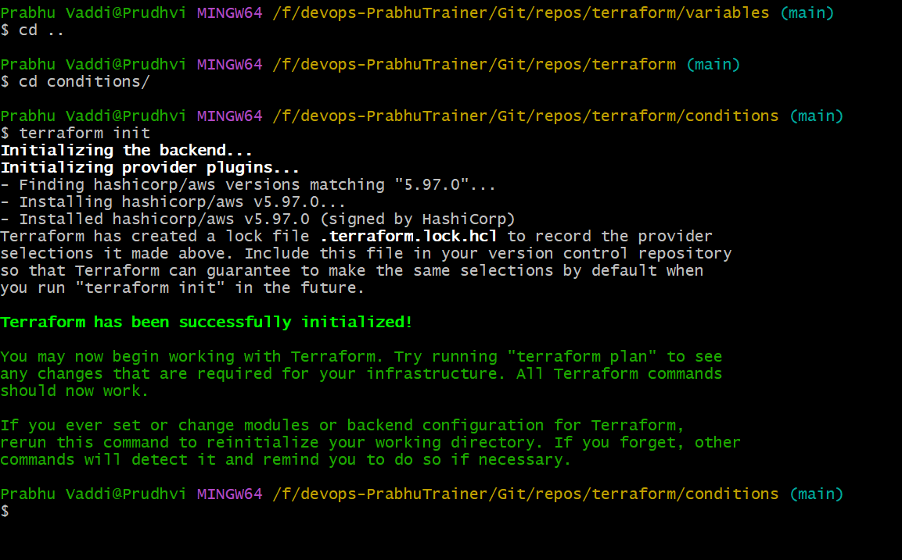

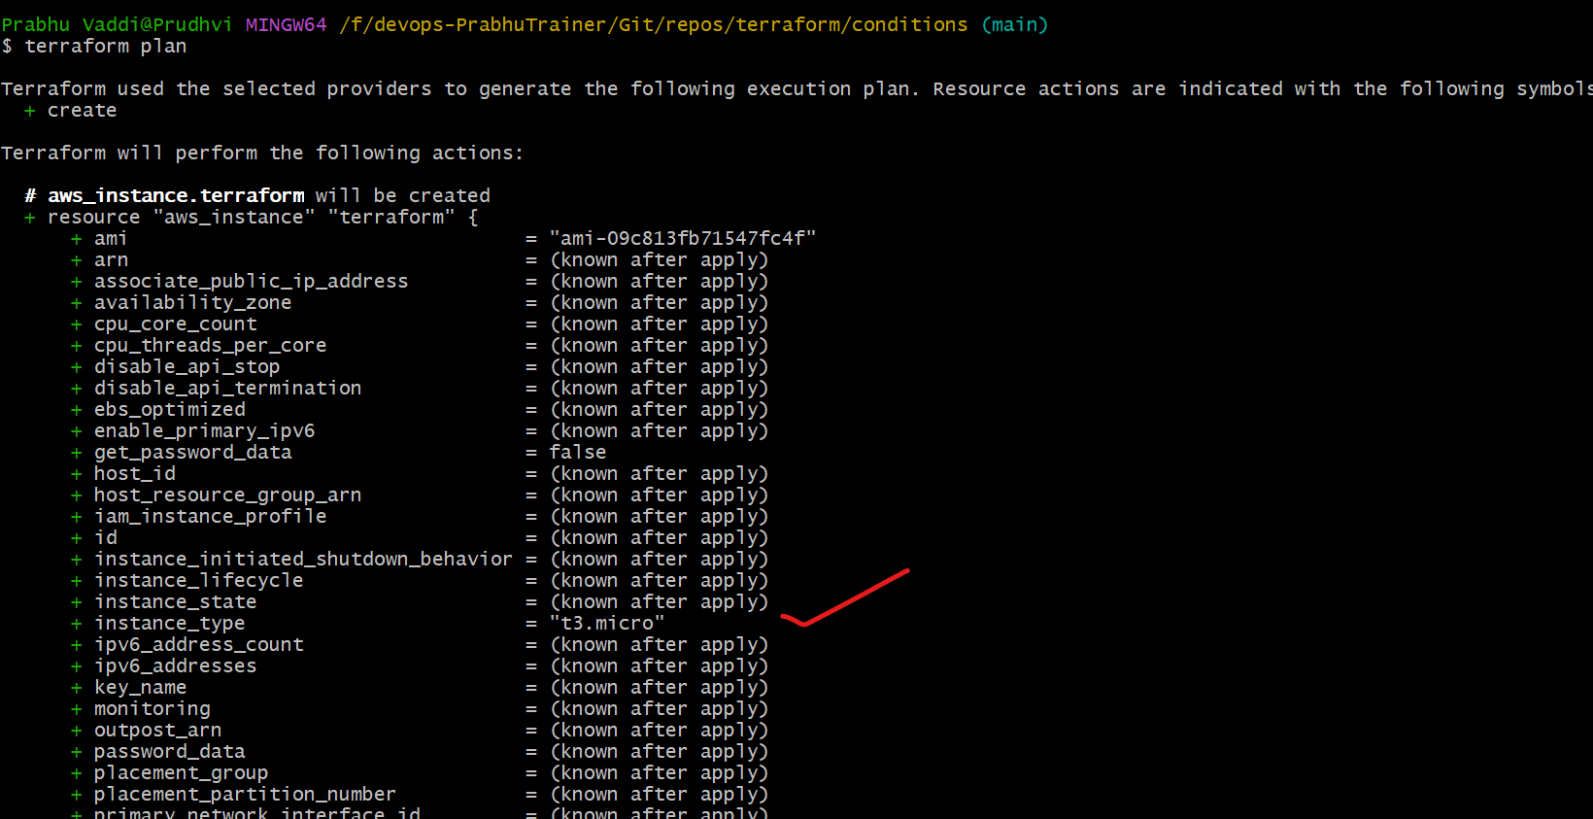

**ENV – PROD : t3.small**

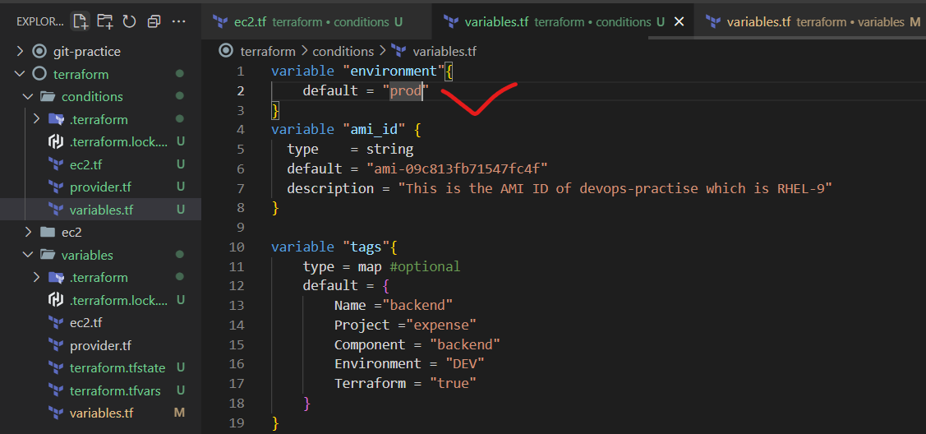

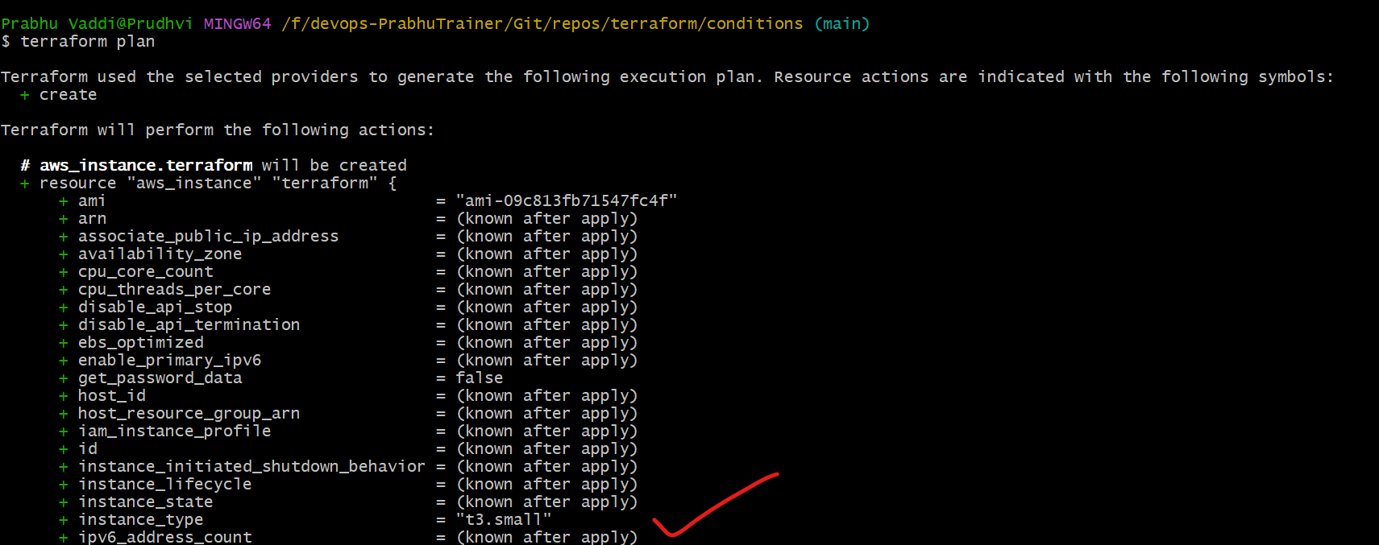

**OUTPUTS**

**We can use terraform output things, whereever u want**

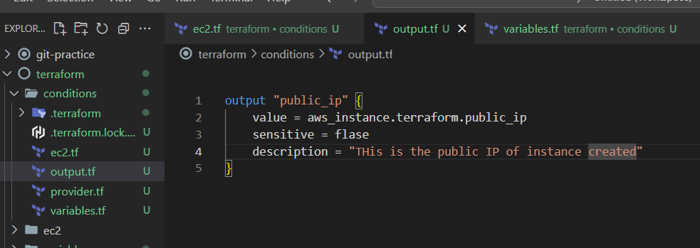

**Terraform plan**

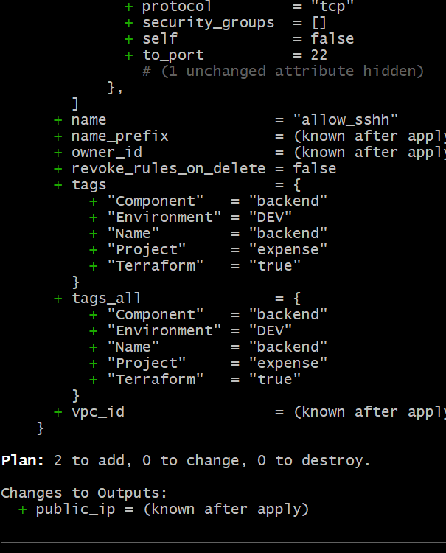

**Terraform apply**

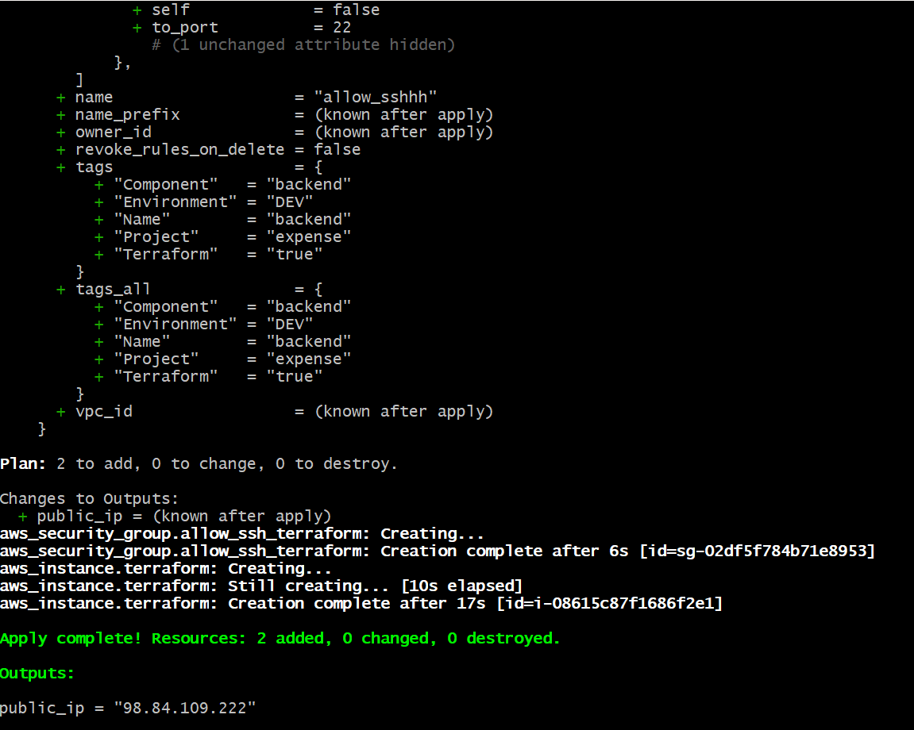

**Validate IP Public both are same**

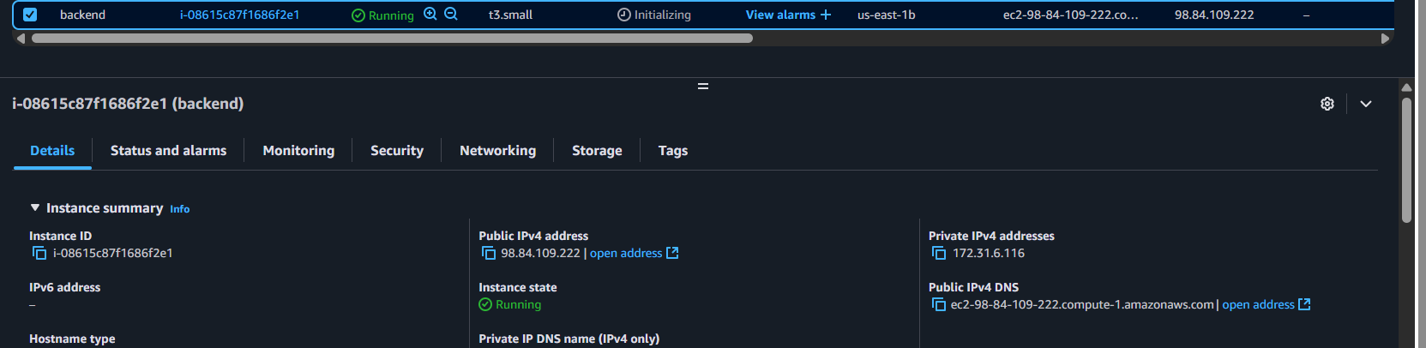

**DESTROY Resources**

**terraform destroy -auto-approve**

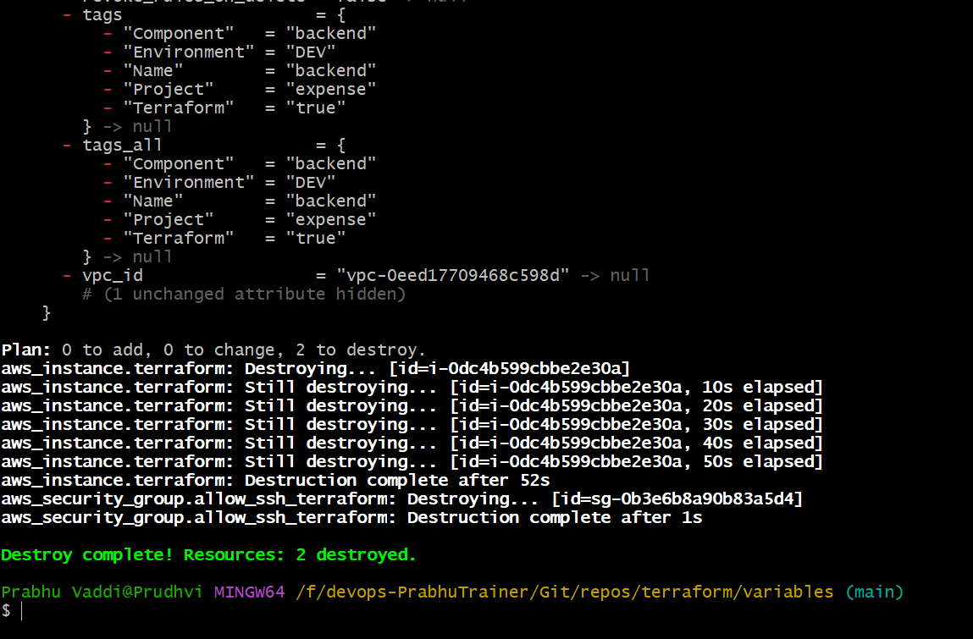

**LOOPS**

**1. Count based loops**

**2. for or for-each loops**

**Folder name – count**

**Count = 3 instances**

**Tag name = backend**

**Resource name = backend in ec2.tf**

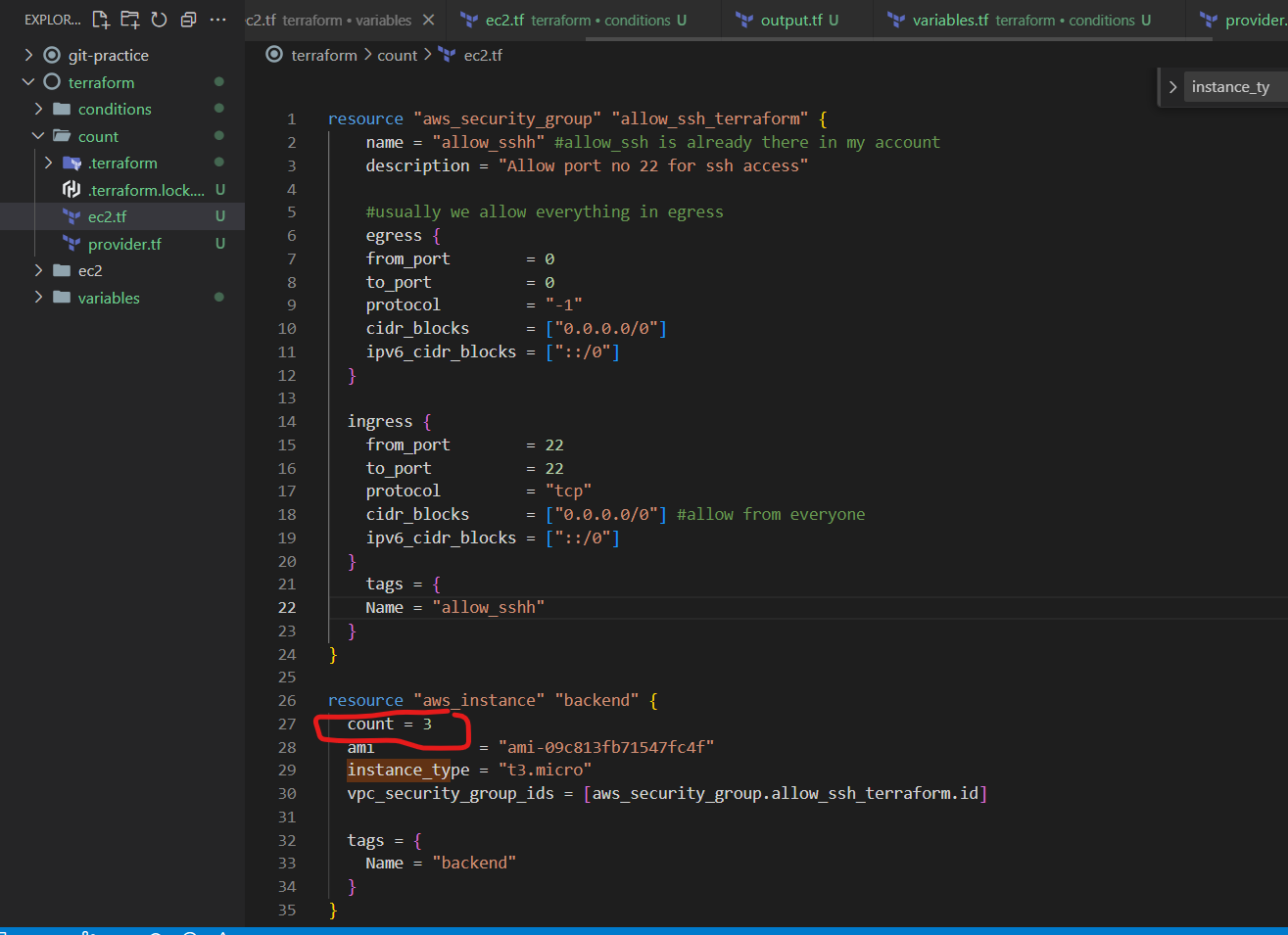

Terraform init

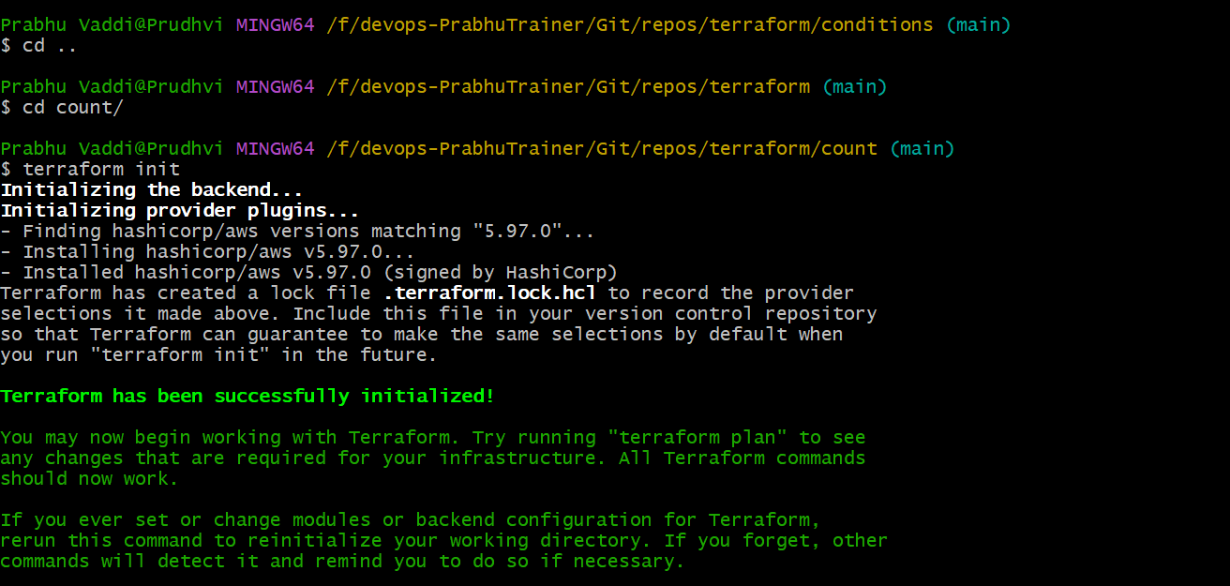

Terraform plan

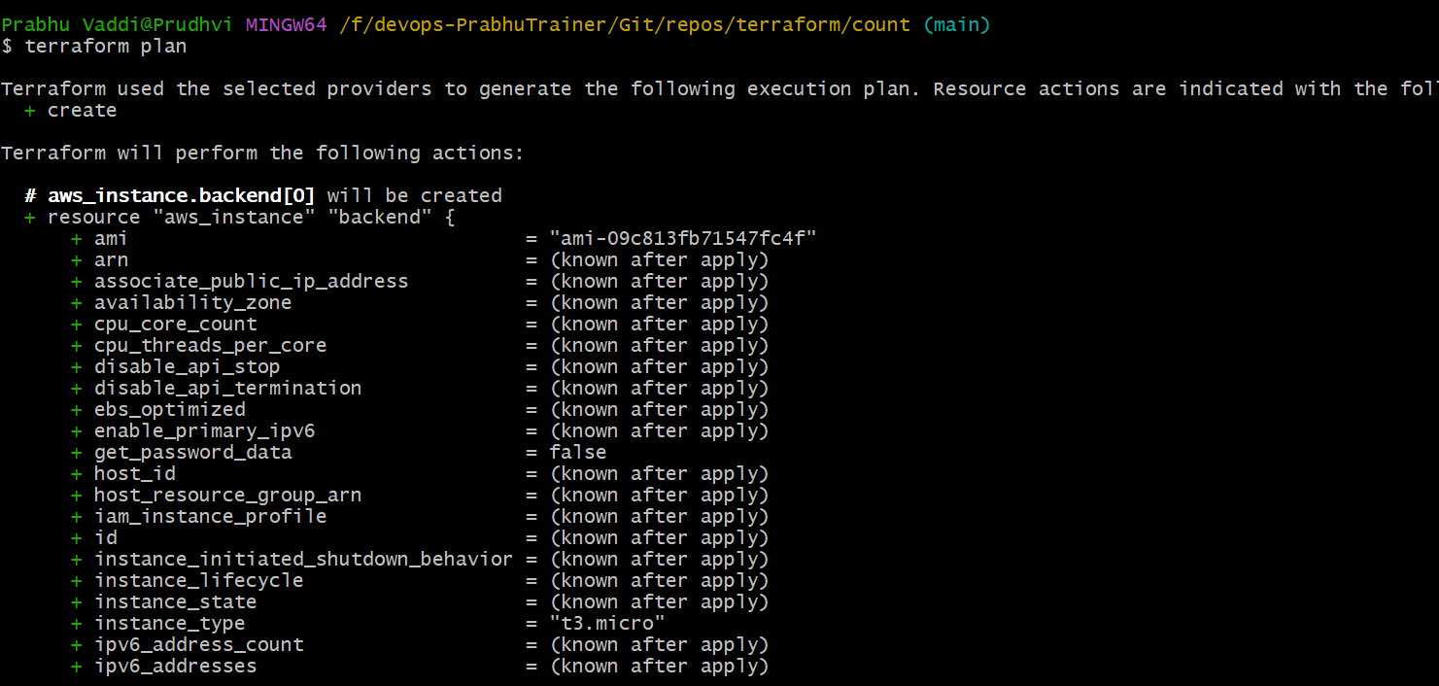

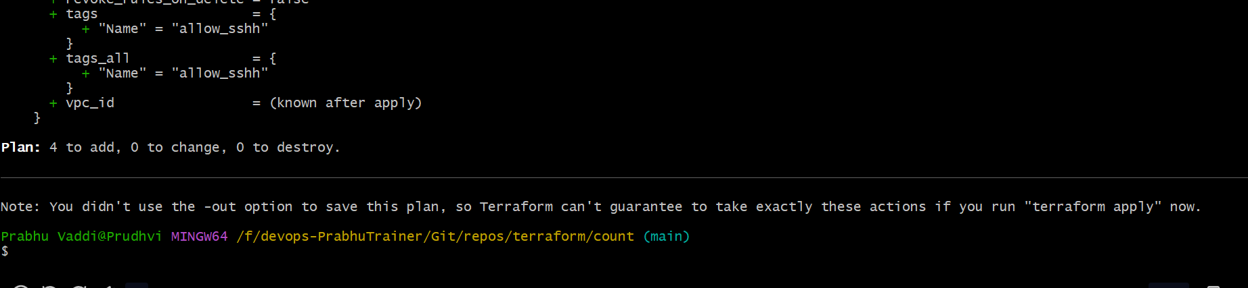

Terraform apply -auto-approve

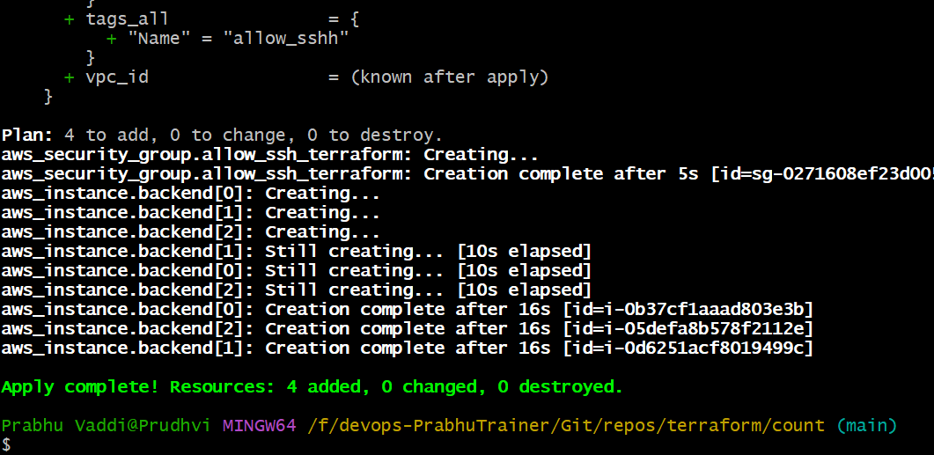

Validate EC2

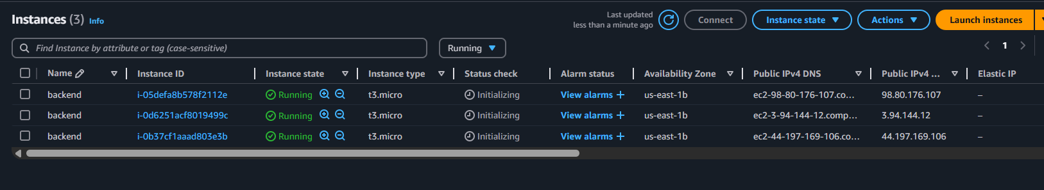

Problem – SAME NAME not correct

Count.Index formula for a list => Create a variable=> use list

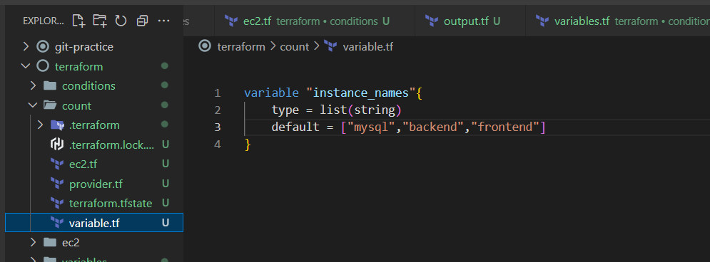

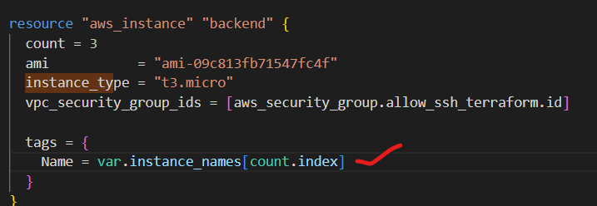

Update the tags using “Terraform apply -auto-approve”

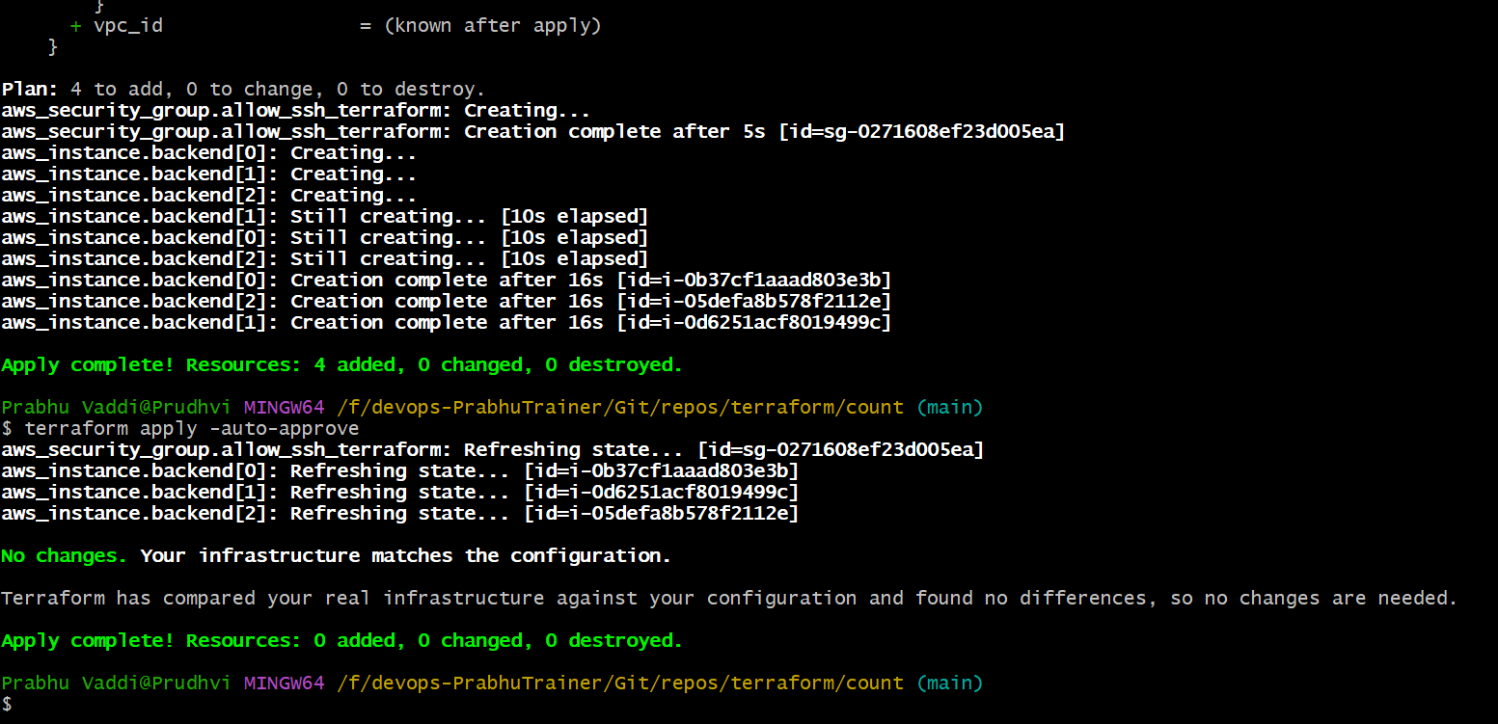

Validate EC2 intances

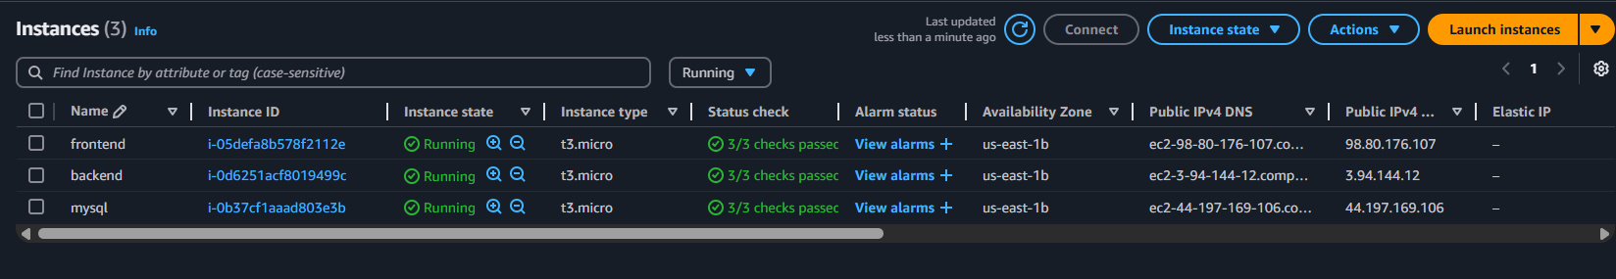

**GIT COMMIT & PUSH ERROR MESSAGE- Solution**

**Warning message**

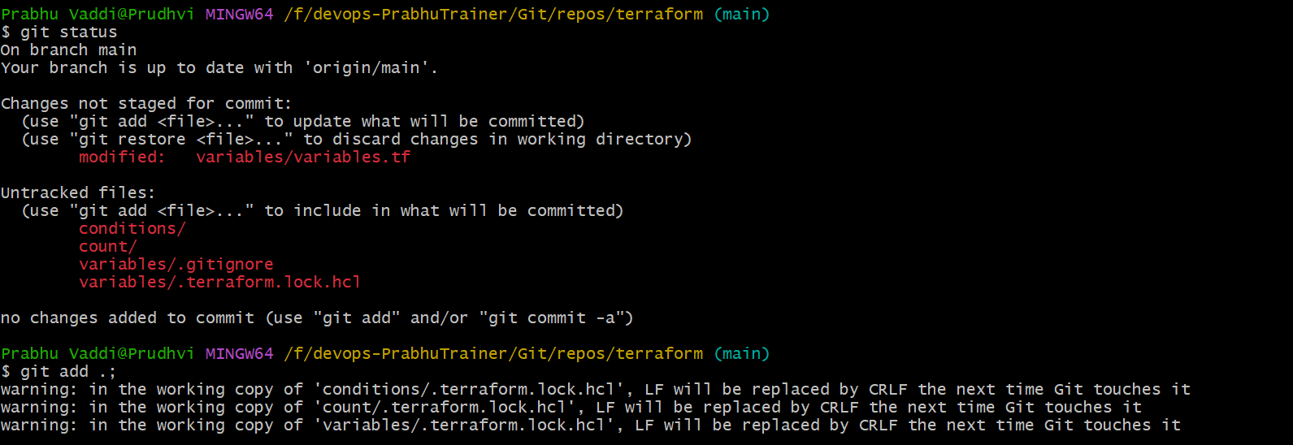

**Git Status**

**Main Option**

1. Or, use a text editor like **VS Code** or **Notepad++** to convert line endings:
   * In VS Code: Click bottom-right corner where it says CRLF, change it to LF, and save the file.
   * NOTE: .gitignore file exists in Project level.

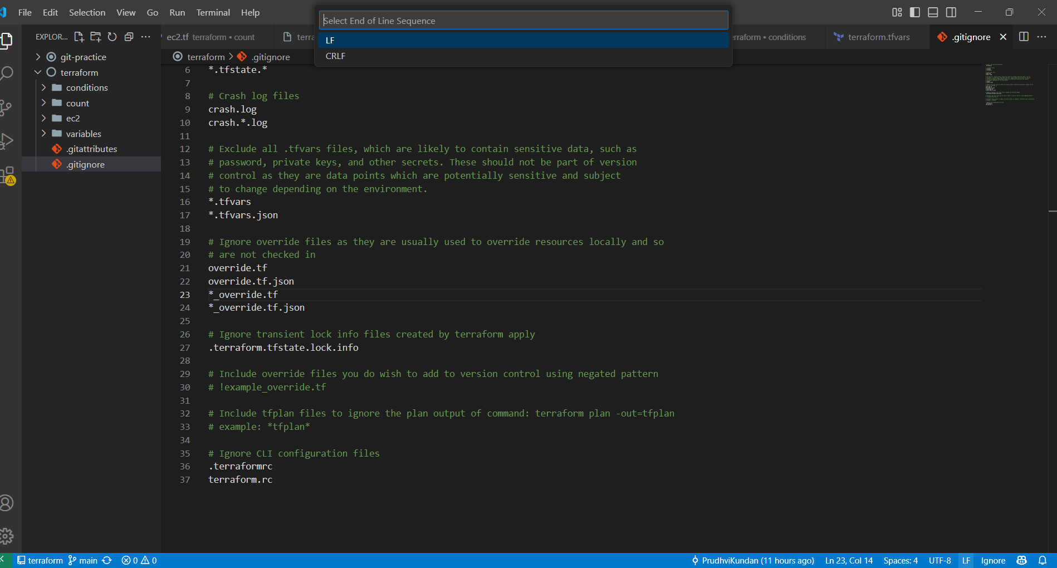

**O/P**

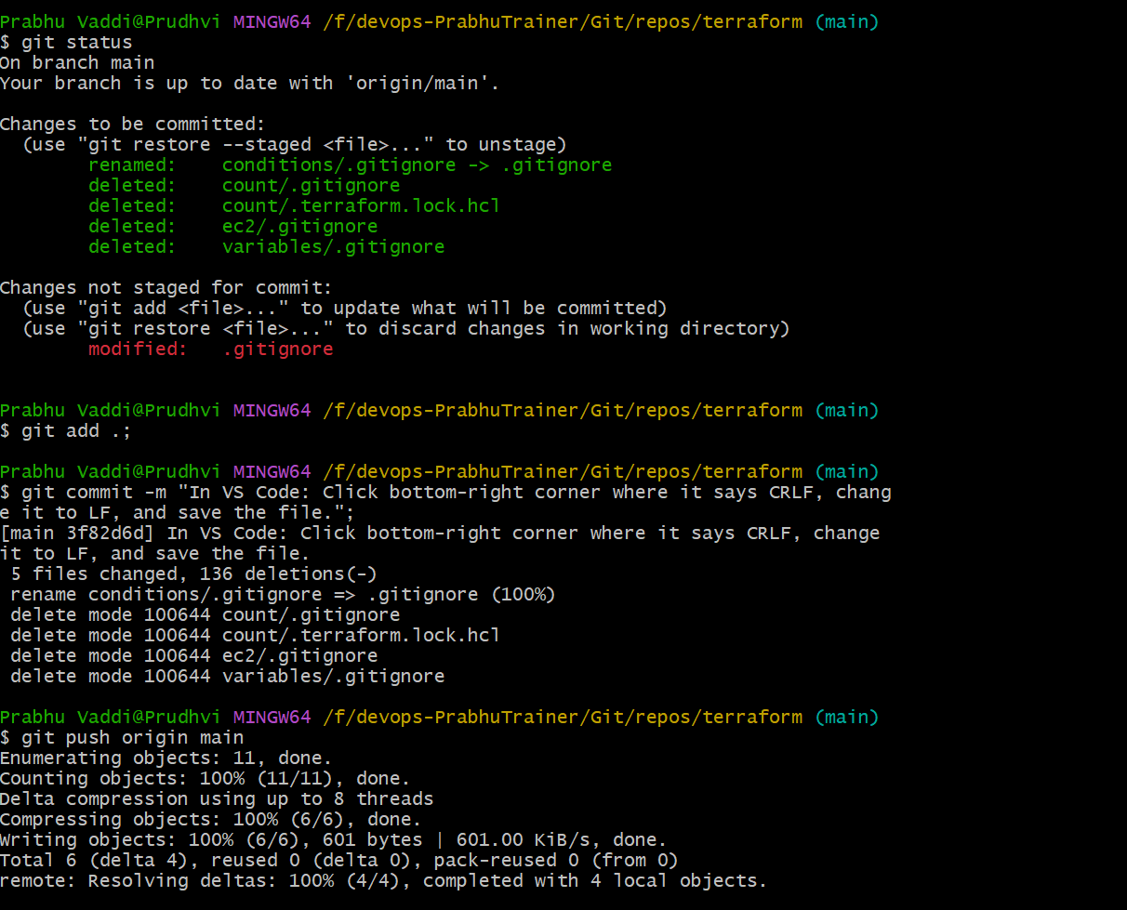

**.gitattributes not required.**

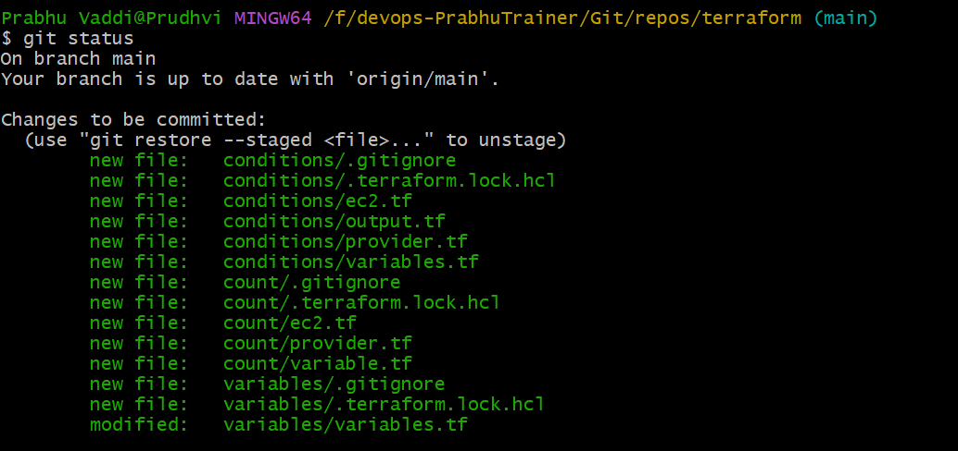

**Step 1: Set Git to preserve LF endings**

CMD: git config --global core.autocrlf input



**Step 2: Add a .gitattributes file**



**PASTE & Save it: Recommended .gitattributes for Terraform/DevOps Projects**

# Enforce Unix-style LF line endings

* text=auto eol=lf

# Terraform files

*.tf text eol=lf

*.tfvars text eol=lf

*.hcl text eol=lf

*.json text eol=lf

# Shell scripts

*.sh text eol=lf

# YAML/Ansible/Kubernetes files

*.yml text eol=lf

*.yaml text eol=lf

# Ignore binary files from line ending checks

*.zip binary

*.exe binary

*.tar binary

*.gz binary

*.png binary

*.jpg binary

*.jpeg binary

# Prevent .terraform folder from being tracked

.terraform/** filter=exclude

# Ignore Terraform state files (just in case)

*.tfstate text eol=lf

*.tfstate.* text eol=lf

CMD : cat .gitattributes

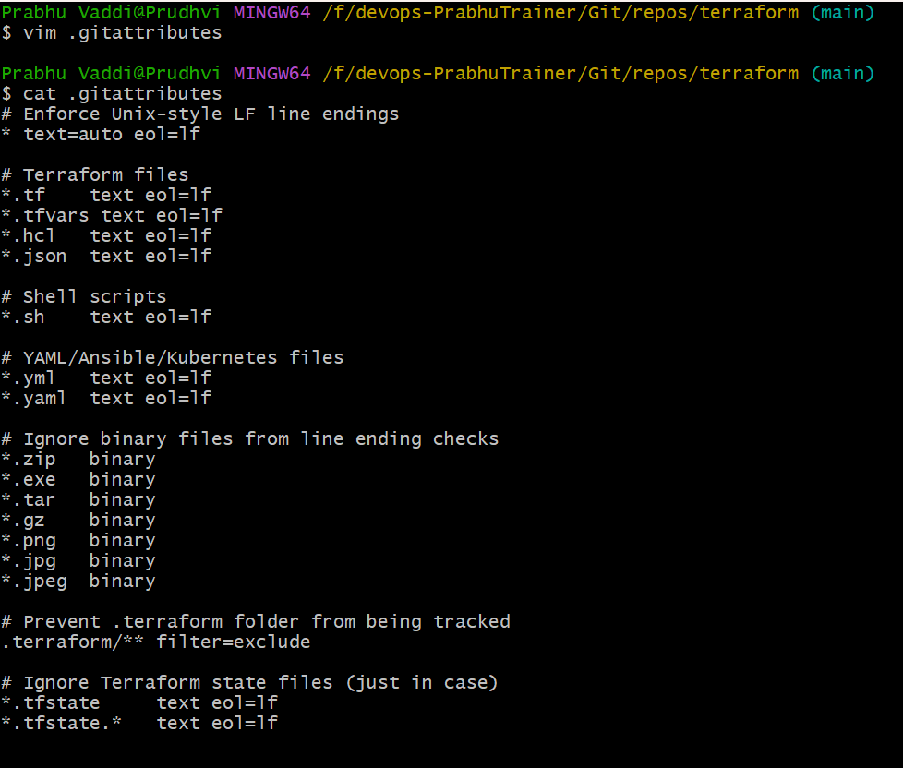

**GIT STATUS**

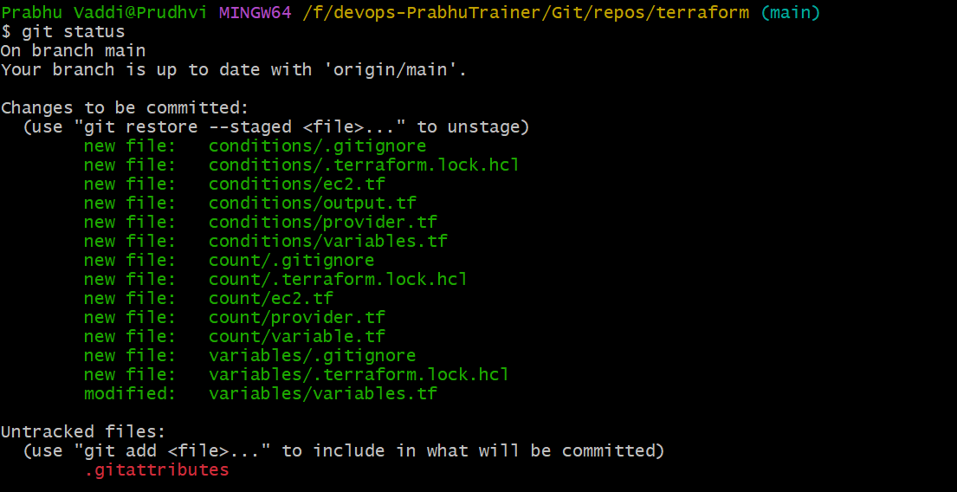

**GIT ADD & COMMIT**

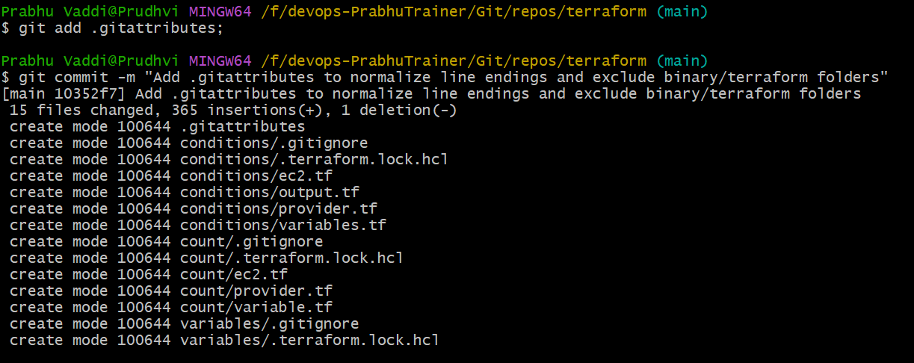

**FINALLY: GIT PUSH**

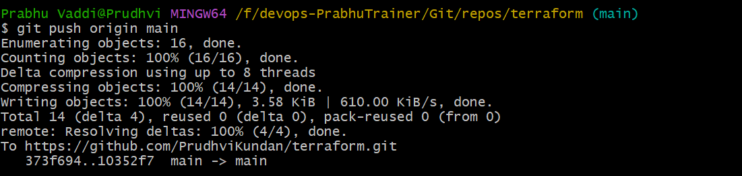

**VALIDATE GIT REPO -**

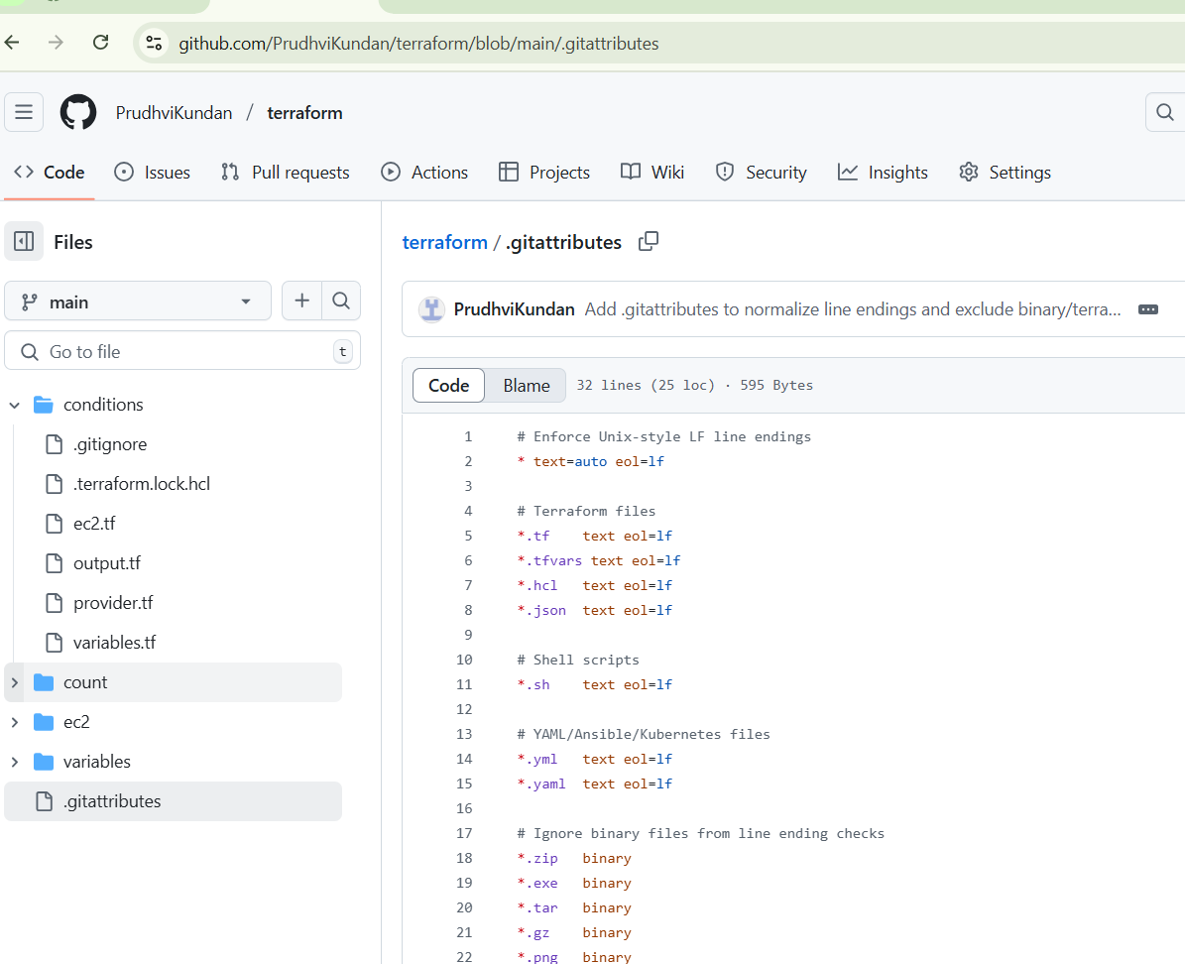

**FUNCTIONS**